Chapter 9: CBA grows, and grows, and grows

CBA was exploding with projects. To the Amherst community, many of these projects looked like we had gone crazy. Twenty-five cats and a monkey chasing around our lab. A violinist, in shorts and a tux jacket, serenading the parking lot. Droves of women leaving the lab with wires coming out of their underwear. And a lot of the powerfully bulked athletes who came could have been confused for Chechnyan thugs. Not to mention, some of our staff looked like mountain men. What, everyone wondered, were we doing?
That said, we were making national news everywhere we turned.
The action started once I got back from Munich. I returned home only to find some sabotaging techniques taking place here, too. At first, I didn’t see them coming. Ann and I were working on at least 5 projects at our kitchen office, I was studying 6 courses and writing for various publications, coaching Field Events at U Mass, as well as training athletes every afternoon in the weight room.
Now, added to this, Dr Campney, the Dean of the Exercise Science Department, offered me an Assistant Professorship to teach courses of my choice.
This was a major thrill for a man whose face had been drawn onto a shotput. I was now an Academic. Dr. Campney was a man whose toughness and low voice put fear into most of his students. But he was not that way with me. He could see that I was doing exploratory work that was getting national attention and he had the foresight not to want the University to be out of it. I devised two courses, “Logic of Movement” which integrated Biomechanics to Cybernetics, and “Computer applications for Movement Analysis,” which covered the programming I developed for my Biomechanical Applications. I presented my course syllabus in a department meeting.
Immediately, my nemeses, Dr. Ricci and Dr. Plagenhoef, my old professors, said “No.” It was a conflict of interest for a professor to have an outside business and interests. I should not be hired at all. Maybe it was my driving up to my first Departmental meeting in my new Corvette! They just could not take it anymore. My biomechanical business, a field they had spent their lives studying, was taking off. Now to make matters worse, everywhere they turned they were reading about me.
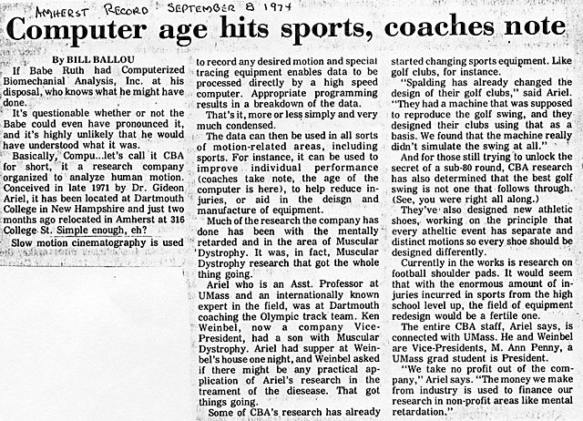
“Dr. Ariel’s company can generate data that can be used in all sorts of motion-related areas, including sports. For instance, it can be used to improve individual performance. (Coaches, take note the age of the computer is here), to help reduce injuries, or aid in the design and manufacture of equipment. Much of the research the company has done has been with the mentally retarded and in the area of muscular dystrophy…. Ariel who is an Asst. Professor at UMass and an internationally known expert in the field, was at Dartmouth coaching the Olympic track team. Ken Weinbel, now a company Vice-President, has a son with muscular dystrophy. Ariel had supper at Weinbel’s house one night, and Weinbel asked if there might be any practical application of Ariel’s research in the treatment of the disease. That got things going.”
That wasn’t really how it started, but you know the press.
The attention I was getting, the money I was making at CBA, drove these two Professors crazy. Professors Ricci and Plagenhoef decided to sue the University for “Hiring Policy Abuse.”
Dr. Campney stood up and said, “Ridiculous. I am hiring him.” Unfortunately for them, this too became a headline.

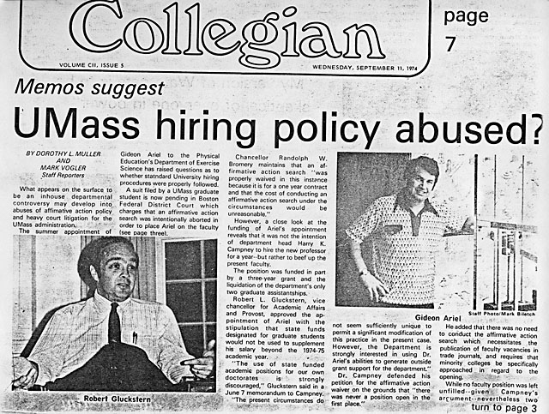
One of many of the local papers headlines
The news papers began writing about an in-house departmental controversy about abuses of affirmative action and a specific filing for “heavy court litigation.” According to the papers, the department head Harry K. Campney hired a new professor (me) to “beef up the present faculty.” Why wouldn’t a department head want to beef up his faculty?
Nothing was decided. And regardless of the pending suit, Dr. Campney and Dr. Arbib kept me on in a joint appointment between the School of Exercise Science and the Computer Sciences department.
The press was right about our work. It was true that CBA was studying muscular dystrophy very closely, and it was also true my partner Ken Weinbel, the Dartmouth College head track coach and the 50 percent partner in CBA, had a son with the disease. This illness is characterized by progressive skeletal muscular weakness. Muscular Dystrophy patients are treated with special drugs to slow down the deterioration.
The question we wanted to figure out was what is the progression of the disease and how does it affect the mobility of the patient. With biomechanics, we could use two or more cameras to film and compare the walking movements, for example, of children with the disease to children with normal walking movements. In this way, we could measure the level at which the disease progressed. We worked on this project with the Hanover local hospital. After collecting all the data, I would meet with Tom Sullivan, the night director at the computer room in the University of Massachusetts. Tom would run the batch programs with thousands of cards at 2 AM, so in the morning I would have the results. Otherwise I would have to wait 2 days. Tom was an innovator himself. I remember discussing with him (in 1972) the potential of Hydrogen Fuel for cars and using Solar Energy for electricity and heating.
One particular evening, I invited Tom to meet Ann and I at the Yankee Peddler for dinner. I would pay for a great dinner, I said, and why don’t you bring the computer outputs with you?
Tom came with a vast roll of papers. I began discussing with him Ken’s son’s walk and how the gate data showed the rate of his deterioration.
Three gentlemen were sitting at the next table having dinner, talking about bank functions and numbers, which I could vaguely hear but was not interested in.
“Excuse me,” one of the gentlemen interrupted us. “Did you say you analyze muscular dystrophy?”
I said “Yes,” and started explaining what I was doing. One man, with an impressive face and an air of authority, became very attentive in his questioning and listened intensely to my answers. Then he introduced himself as Larry Graham. It turned out he was the president of the Holyoke Hospital and also owned the local bank in Hadley, Massachusetts, a nearby city. He invited us to join their table, which we did. I told him a bit about the Olympics and East Germany. Ann told him about her work on the nervous system and, of course, with her English, she was easier to understand than I am with my Israeli accent. He insisted on paying for our dinner and asked if he could visit with me so I could show him the methods I was using.
I warned him that I worked from home and even though I used state-of-the art science, and state-of-the-art computer technologies, I sat at a desk in my kitchen. He did not care.
We agreed to meet two days later.
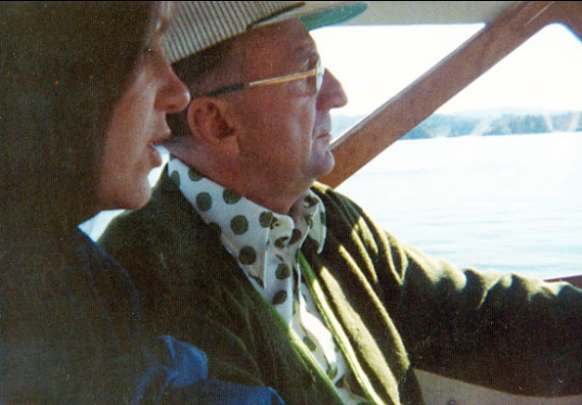
Larry Graham and Ann
That Thursday afternoon in October, 1973, he knocked on the door of our small house in Belchertown. Ann was digitizing data related to the 1972 Olympics. I was on the teletype connected to the University computer.
Larry Graham looked around and began taking in all we were cooking up in our kitchen. He carefully looked at the publications, data sheets and the digitizer stuck on the wall. He went downstairs and looked over the full Universal machine sitting next to a window overlooking the lake. He carefully looked at all the cameras pointed at the machine. He was very thorough and asked a lot of questions so that hours seemed to fly by and suddenly, I thought, Well this was a pleasant waste of time.
Then Larry stood quietly thinking in our kitchen, finally turning to Ann and me. “Okay you guys. This is not the way to run a business. Your potential is great, but you’re working an armature of an operation.”
“Mr. Graham, “ I said. “What would you suggest?”
To my surprise, he said, “Give me a chance and I will get you up and running as a successful business.”
And this is how our company and our life changed. All from a dinner at the Yankee Peddler.
To begin, Larry checked our books which were very messy, but even so, he could see we were even now profitable. He then said that he wanted to rent an office for us in a better place and he himself would purchase all the equipment that we needed.
“I have a partner, a Mr. Weinbel,” I said, “and we need to meet.”
The next week we all met in Hanover, New Hampshire at Ken’s home. Everybody was agreed and enthusiastic about growing and we decided to share the company, one third each between Ken, Larry, Ann and me. And this was the beginning of the new CBA, with Larry.
Before we started, Larry wanted to conduct a due diligence study with an independent company to gauge the upside potential of CBA. Larry recognized that, like most inventors who own companies, I am a dreamer, and what could sound a good idea to me may not have commercial value. Larry’s intention was not only to create a company, but to make sure this company would make a profit and stand on its own.
Cliff Lewis, at Marketing Communications Inc, was assigned to study our company. The person in charge of the research was Professor Bither at the Amos Tuck School, a leading professional school at Dartmouth College.
The report consisted of some 100 pages covering all of CBA’s potential advantages and disadvantages. Their main points were essentially:
- CBA represents the first incorporation to bring biomechanical analysis to commercial usefulness.
- The market potential was unlimited. Biomechanical analysis had potential use wherever forces are applied in a biological link system, ie living animal, human, horse, etc.
- Commercial uses could include the entire market for athletic equipment design. The entire market for safety equipment design. Protective and athletic apparel design (e.g., ski boots, special shoes for various purposes) etc. Insurance settlements (especially with disability claims) is another potential market. The design of artificial limbs. The design of surfaces which the body comes into contact with. Clinic opportunities for golfers, tennis players, ballet dancers, professionals and amateur, etc.
In short, Larry saw a gold mine and decided to go ahead without delay.
It was only a few weeks before Larry found an office for us on Route 9 next to Amherst College. The space was between a sandwich shop and a paint store at 316 College Street. It was a simple office, with a large open space for all our technology, and 3 small offices for us to make calls in. However, the investment Larry made in us was immense. It included furniture, new terminals, an oscilloscope, a new digitizer, a memory saver terminal by Techtronic, and new high speed cameras which operated electronically, not with the old loaded spring. He never told us what his investment added up to, but I believe it was around $100,000 (now worth $500,000). We were ready to go big time.
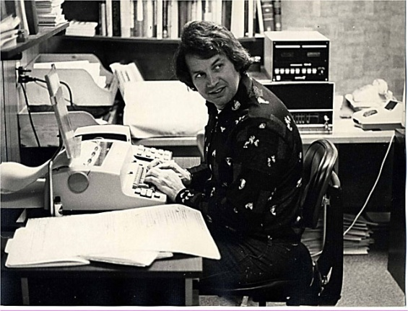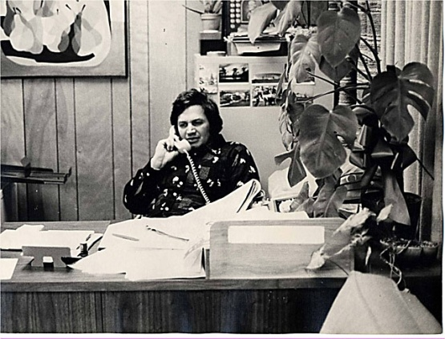
Our new Office in Amherst on Route 9
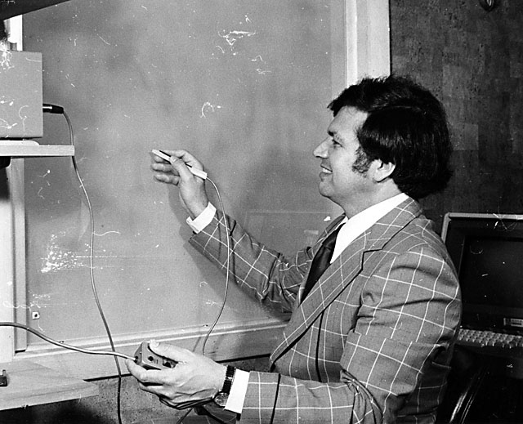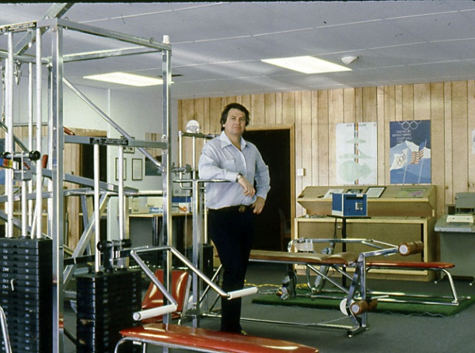
Our new equipment and the new Universal Machine in our new office in Amherst
Our staff became an amalgam of brilliant, and hence eccentric, personalities. Ann ran the whole office and did hours and hours of manual digitizing. Carl Peterson was a programmer from Dartmouth College, a fast, creative programmer in BASIC and, together, he and I created the original biomechanical software in 1971. Another programmer was Alan Blitzbleaw who worked in the Computer Center at the University of Massachusetts. His specialty was FORTRAN and APL languages. Alan was responsible for many of the software modules that we developed and worked with me for 18 years. Another contributor to the software was Jim Walton, a student from Penn State University, who was dedicated to 3D analysis, and developed that part of our program. I had also two genius students working for me, Peter Smart and Justin Millian. Both were hardware and software specialists and they helped out creatively in many parts of our development.
But the most important programmer in our history literally came off the street.
One day, I was working in my Amherst office, busy with some tennis project. It was 1974,so we had been open for quite awhile. People were always curious about what we actually did. I was used to unexpected gawkers. This time a hippie, whose hair was so long and his beard so covered his face that he resembled a bear more than a man, knocked on the office door. I opened the glass door and thought I’ll give this homeless man a few dollars.
Instead of asking me for money, he asked,“What are you doing here?”
“Some scientific work with computers.” I thought that would do it and reached into my pocket.
He then focused on our Data General Nova-3 computer. “I know that computer,” he said, “and I can help.”
I scratched my head. “What’s your background?” I asked.
I found out that he had a PhD in Nuclear Physics and worked in the Physics Department of the University. Much later, I found out that Peter and Justin were two of his students.
But at that point I wasn’t sure he was telling the truth. A lot of people at that time had taken so many drugs they thought they were Jesus Christ. He could see the skepticism in my eyes.
“Ask me to program anything,” he said.
“Why don’t you program the stock market for me?” He asked for details. I told him to learn the symbols, including options and puts etc., all the functions used in the stock market exchange. I told him that I would pay him $10 for each hour he spent on it and to come with the finished product. What ever it takes, I said, he did not need to worry about getting paid. The minimum wage at that time was $4 per hour. He agreed and left the office.
Four days later he came back. “I never asked you your name,” I said.
“Jeremy Wise.”
“How’s the project going?”
He answered, “I finished it. Do you want me to demonstrate the results to you?”
We stood over a computer together and he took me through what the software program in detail. Nothing was left out. I could not believe it. It would take me at least a year to do what he did in a few days. I said, “Jeremy, you are hired.” So, Jeremy started working with me in 1974 and he is still working for CBA, as you read this book. His contribution has been a mainstay of the company. Together we created the most sophisticated biomechanical programs in the world from 1971 to 2011 and we’re still continuing strong. We created software for mainframe and personal computers, as well as a computerized Exercise Machine. Our working relationship has always been strong, personal and unbreakable.
Meanwhile, Universal was looking for more input on designs. With our new lab in Amherst we could provide Universal with much more information. Universal sent us all the hardware that they wanted us to reconfigure. They wanted us to follow this basic principle:
To create a machine that helped exercisers maximize their strength at every load. When the human lever is in the position of the greatest biomechanical disadvantage, commonly referred to in weight training as the "sticking point," a person needs the maximum of muscular effort. When the human lever system is at its greatest advantage, the muscular force diminishes in order to lift the same maximum external load. Therefore, the variability that exists in muscle force is due primarily to the changing advantages and disadvantages created by the human lever system.
The following examples will illustrate the changes in muscular forces that can occur:
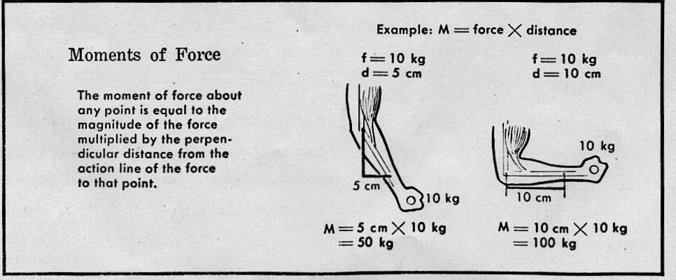
- By understanding this important human phenomenon, it is relatively easy to establish that muscles work at their maximum potential during only a very small range of total movement (normally only at the "sticking points").
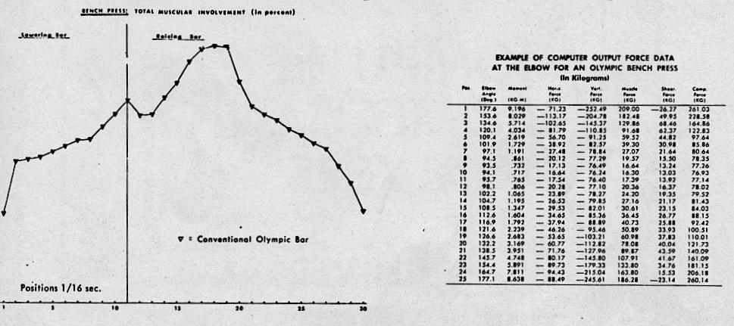
- In order to develop maximum conditioning effectiveness, it is an absolute requirement to accurately vary the resistance. Only then is it possible to maintain the same degree of muscular involvement (efforts) throughout the entire range of movement.

So now CBA was contracted to build exercise machines that:
- Re-tested Leg Extensions to determine new muscular outputs (Force curves) and adjust resistance intensity if needed.
- Tested for the resistive formula for a "standing" leg curl exercise.
- Tested the resistive formula for lat pull down exercise on Universal hi-pulley station.
- Studied variables for junior-age boys. This data would be incorporated into the design on a new and smaller junior high machine.
5.Tested resistive formulas for women for the bench press, shoulder press, lat pull down,hip swing - abductors, & adductors.
6. Determined the resistive formula for seated arm curls and triceps extension exercises.
7.Determined the resistive formula for pullover exercise - both from prone and seated positions.
- Determined the resistive formula for neck exercises - lateral, rotation, and extension and flexor.

We were paid for these projects and expenses and, in addition, we received 33% of the profits derived from machines that reflected these efforts. This was a huge amount of money. I decided to try to share some of the money with the University since I was an Assistant Professor there and they had contributed so much to my knowledge to be able to do all these projects. Here is the letter from Dr. Campney to Mr. Zinkin of Universal:

Mr. Harold Zinkin,
Executive Vice President Universal Athletic Sales 1328 No. Sierra Vista Street Fresno, California 93703
Dear Mr. Zinkin:
Your letter of December 24, 1973, must have been delayed for days in the mail due to the holiday rush. When it did arrive, I was away from my desk for a few days. I apologize for not replying sooner. The delay should not be interpreted as a lack of interest on my part.
We are most interested in Gideon Ariel's ability, his work, and his potential for contributing to a better understanding of how man moves. For example, I am attempting to secure a position on our faculty for Gideon for the 1974-75 academic year. However, there are a few obstacles in my way at the moment.
We are most interested in cooperating with you in any way which will contribute to Gideon's work. I agree that we should discuss this situation as soon as possible. I can come to California for this purpose or, if you prefer, I would be delighted to receive you here in Massachusetts.
Since the matter of Gideon's future is my first priority at this time, I hope we can arrange a meeting soon. I am available at any time, but I think that Gideon should be present during our discussion and his schedule is something else. For instance, he leaves for Spain tonight!
Sincerely yours,
Harry K. Campney, Head
Department of Exercise Science

The meeting took place later on. However, Dr. Ricci’s and Dr. Plagenhoef’s legal suits ruined the University’s chances for a joint partnership. Universal also did not want to be mixed up with the enmity with these professors, nor did they want to be embroiled in the midst of a litigation (neither did I!).

Now we added some huge projects to our list. We used our biomechanical technology for a different business. A business of the future. A business that would make us well known. An unlimited business.
We went into the shoe business.
At my 1972 scientific presentation at the Olympics, I was approached by Mr. Hans Brink, the head of Public Relations for the Adidas shoe company, the largest shoe company in the world. He wanted, he said, to discuss some of my ideas.
“Which ideas?” I asked him.
“Particularly, we are interested in what you said about how it doesn’t make sense that someone wearing a shoe size 11 and weighing 100 Kg. would wear the same model shoe size if he weighs 75 Kg. You said the shock absorption should be different for different weights.”
“Yes,” I said, and showed him some preliminary work we had been doing for the National Bureau of Standards concerning Sleep and Fall situations with the shoe and the surface interaction.
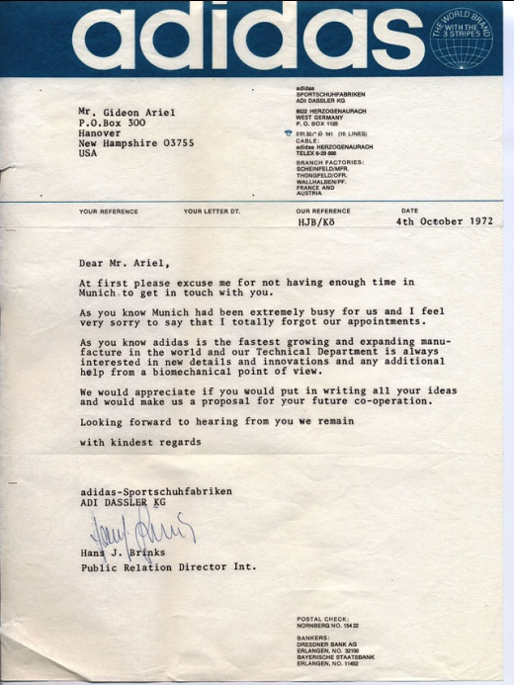
Hans Brink then wrote me that Mr. Adi Dassler, the President, wanted to meet me. They even would fly me to Herzogenaurach, the city of Adidas, to meet with their staff and engineers.
A few months later I participated in a conference in Munich, Germany and made the decision to go visit with Mr. Dassler and his engineers.
Our morning was full of discussions of biomechanics and my models and what we could do. It was now time for lunch. Before we were to leave together, Mr. Dassler asked me come to his office. We both walked slowly to his office, and upon entering it, I thought I had just flown to outer space. He had all high tech solid gold furniture as well as gold shoes on display, an office that must have cost millions of marks to build. But what did I expect from a 100 percent owner of the largest shoe company in the world?
He then took me into one of the closets in his office and pulled out a beautiful neat SS officer uniform.
I was in shock, it was a strange show and tell to give an Israeli, and asked him if he had been an SS officer in the German Army in World War II.
He admitted that he had been, but made the following statement: “My responsibilities were against the Germans, not the Jews.”
Immediately I made the comment: “Well the Germans only fought the Germans, right?”
We did not discuss it anymore and went onto lunch with Mr. Vogler, the chief Adidas engineer. We discussed many ideas and basically their interest in “the athlete in the shoe.” They wanted to measure the forces in the shoe and how the body reacts with the athletic shoe.
After the meeting, I received a letter that Adidas was ready to work with the University of Massachusetts through me to develop their new lines of shoes. What an opportunity this was! I showed the letter to Dr Campney and pointed out to him the enormous potential for the University.
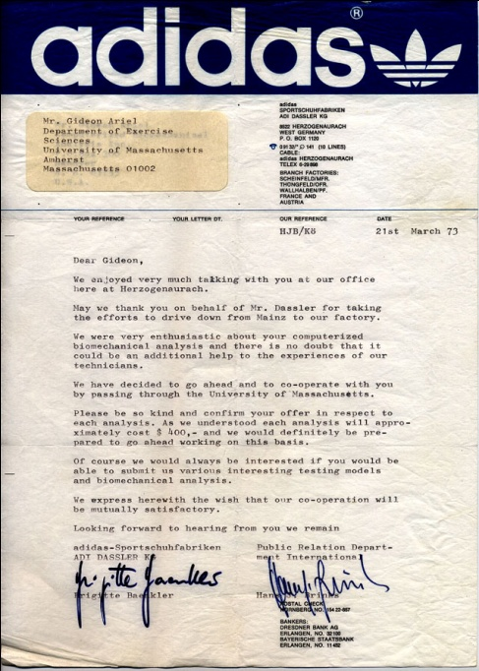

The Adidas letter stated:
“We enjoyed very much talking with you at our office here at Herzogeneurach. May we thank you on behalf of Mr. Dassler for taking the efforts to drive down from Mainz to our factory. We were very enthusiastic about your computerized biomechanical analysis and there is no doubt that it could be an additional help to the experiences of our technicians. We have decided to go ahead and to co-operate with you by passing through the University of Massachusetts. Please be so kind and confirm your offer in respect to each analysis. Of course, we would always be interested if you would be able to submit us various interesting testing models and biomechanical analysis.”
Dr. Campney listened but told me that since we were still in the middle of legal problems with Dr. Plagenhoef and Dr. Ricci, that I should conduct the studies at CBA for now.
What a loss for the University just because two men wanted to fight my being hired because I also worked elsewhere!
My affiliation with Adidas began a whole number of studies on the interaction between shoes and athletes and shoes and non-athletes.
We now had so many projects at CBA that we needed more state-of-the-art technologies. We already had the proper cameras to analyze body movements with their kinematic parameters such as velocities, accelerations, momentum and interaction between the legs and the arms as well as other biomechanical parameters. However, we did not have the mechanism to measure the force on the shoes. For that we needed force plates. The force plate is what measures the forces in all directions when you come in contact with the ground. At that time there was only one company in the world that made force plates. This was Kistler of Switzerland, who later we would end up working with.
But at this time, we simply purchased two plates which cost around $30,000. And we built a mechanism using hydraulics to be able to load the shoes inside and see how the material responded as well as other scientific parameters which are beyond the scope of this book.
In addition, we needed to purchase Electro Myography, to measure the response of the muscles and the muscular involvement at each phase of a stride during various activities.
With the cameras, the plates and the EMG we could measure what the human body was doing inside and outside of the shoe.
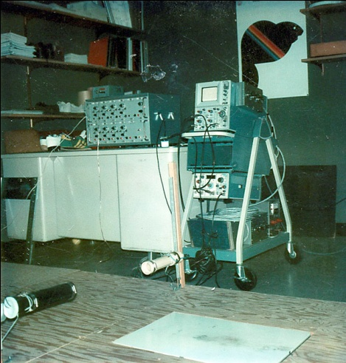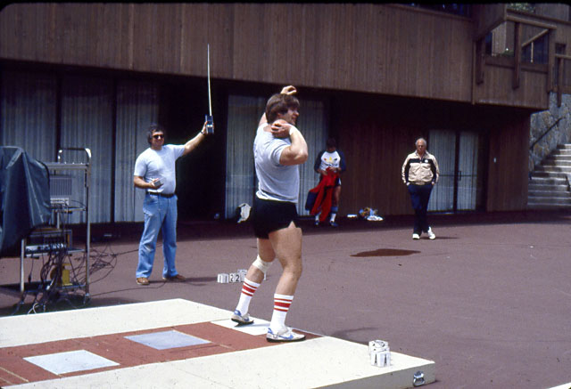
Force plate and its recording device Olympian Athlete perform the Shot-Put throw utilizing 3 Force Plates

In 1972, no one had yet started thinking about how shoes related to the athletes’ actual performance. We already knew that, even in the gentlest of exercise, such as jogging, there is a perceptible change in the elements of each stride when compared to walking.
In our measurements, we found out that many joggers land first on the heel and then they roll forward. This is very different from walking. Joggers are using the force of 3 times their body weight when they land on the ground. This sends a shock wave through the ankle toward the knee, the hip and then up the spinal area. An ordinary heel may suffice for an easy walk, but it will not do for the much greater loads imposed in jogging and, even worse, when running fast.
Some joggers land almost flush on the foot, crashing down on the arch. Other joggers imitate the action of runners who touch down on the forefoot, roll back toward the heel but may never actually bring the heel in contact with the surface before they are back into the swing phase.
From the standpoint of absorbing the punishment of the 3-times-their-weight force, it is preferable to land on the forefoot where the ball of the foot, with its rounded contour and spongy character, can absorb some of the blow.
The faster one runs, the more severe the impact. We measured how the ligaments, muscles and tendons were able to spread the trauma of the touchdown.
We found that the main difference between walking and running is that in order to walk, one must elevate the body and then fall forward. The biomechanics of walking simulate an egg rolling end over end. A walker pushes off almost vertically. Lifting the body, combating gravity, the leg muscles perform positive work. The potential energy of the uplifted body becomes kinetic energy during the fall phase, all the while accompanied by positive muscle movements. Jogging, even at a slow pace such as seven kilometers (4.5 miles) per hour, calls for a substantially different operation. For a runner, the analogy is not an asymmetric end-over-end rolling egg, but instead a symmetrically bouncing ball. The leg actively contracts to prevent the ankle, knee and hip joint from bending due to the weight of the upper half of the body and the generated force.
Our research for shoe designs took us years. We learned everything there was to know about feet. We had to design very specific equipment to measure the forces impacting the shoes in a variety of athletic activities. To do that, for example, we developed a mechanical leg which was controlled by the computer to simulate particular strides of running or walking.
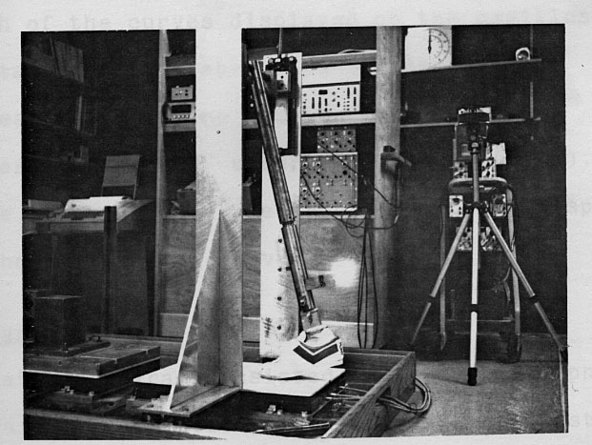
Mechanical Device to simulate Running and Walking

Then we needed to build a machine that would put stress on different parts of the shoes to see how particular parts and material reacted to the force. This mechanism was the only one in the world that worked under compression and tension according to our software instructions.
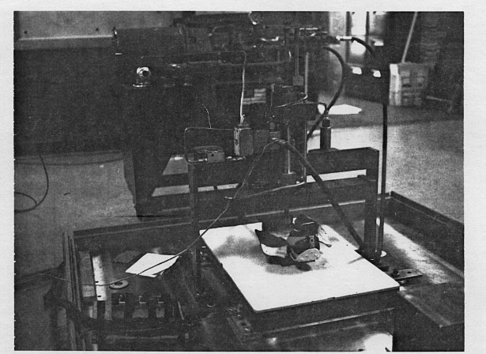
Material Tester to test the response of material to the forces on the shoe, inside and outside
We ended up supplying Adidas with the information they needed and recommendations for redesigns of some of their athletic shoes. They ended up incorporating many of our ideas. One idea that I came up with – an idea that was to stay around for a long time and be adopted much later -- was that they needed to have a shoe that would adapt to the (many varieties and styles of running) foot. How to do this?
“Air,” I said. Adidas had not built an air-shoe yet, but they did venture close at first with a shoe which had sort of “pockets” in the sole to accommodate the forces, the same as automobiles use with inflatable tires.
We also made unexpected discoveries for the shoe business. Some were:
- Sprinters have no need for spikes. The need for shock absorption qualities is also minimal because the body motion is vigorous and effectively counters the landing. The sole should be firm to enhance the push-off.
- The slower pace of the long distance runner and the large number of repetitions of foot contact make friction, wear and shock absorption extremely important. We recommended that the sole flex should allow a smooth convex curve as the heel moves upward.
- A cross country runner should wear the same shoe as a distance runner, but three additions are necessary. Because of the possibility of stepping on small projections (stones, ridges,etc.), the sole must have more rigidity for the distribution of the force. Uphill running causes the forces of impact to be entirely on the ball of the foot, so the sole should have better shock absorption qualities than the flat racers shoe.

- The Olympic walkers have the end of the heel hit first with the toe high, just as the opposite foot leaves the ground. The time of double support is almost nil. The heel has almost no downward force when it touches for the first time because the motion is almost completely horizontal. The inner sole should be soft so the surface will shape to the toes. The uppers must be very flexible to adjust to the drop of the longitudinal and transverse arch. The shoe must be firm fitted about the metatarsals, and form fitted to the heel without putting pressure on the Achilles tendon.
In addition, one major change that should be considered for all track shoes is that a higher heel be used. Light weight should not be sacrificed, and the sprinters heel should be lower than the distance runner. It appears that most manufacturers have taken away the heel to save on weight. The heel should be rounded on the outside-back edge and be edged sharply and be slightly higher on the inside of the heel.
Based on this kind of extensive research, and believe me, there was a lot more, we came up with optimal shoes for each event. Here is one of our optimal shoes for jogging:
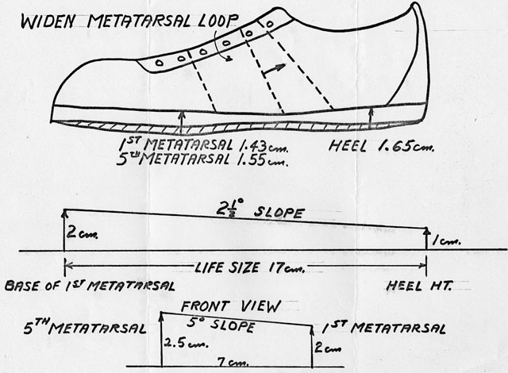
Recommendation for one of our shoes

In 1975, the International Society of Biomechanics met in Yavascula, Finland. I was invited to present a paper on the Design of Athletic Shoes. I had to be careful not to reveal confidential information, but to talk more about the methods that I was using.
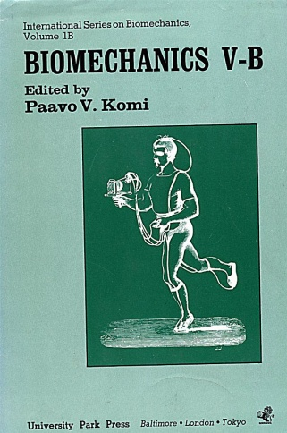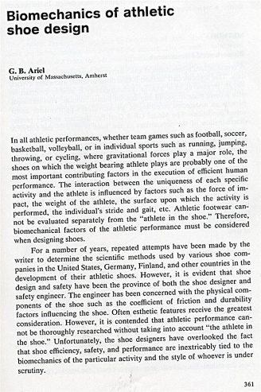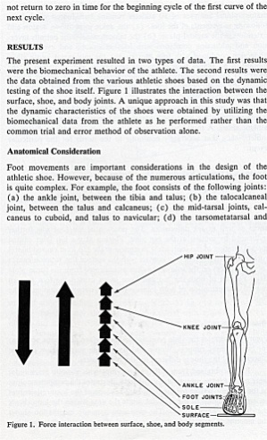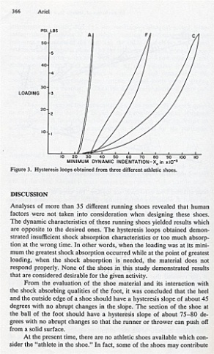
This presentation put us in the forefront of shoe design. Our research for Adidas had given us the knowledge and the equipment that no other company had.
One person who heard about our research for Adidas was Roberto Mueller, an Argentinean who lived in New York. I received a phone call from him, asking about our research. I told him that these studies were confidential and we could not share them with him.
One Wednesday morning, Roberto, dressed elegantly and with the impeccable manners of the South American, appeared in my office. He introduced himself with a heavy accent (although I probably should not talk!). At that time I had some Israelis working with me on various projects. One of them was Avraham Melamed, the one I stayed with at the Munich Olympics who was now a student of mine working toward his Ph.D. at the University of Massachusetts.
Roberto and I were in the conference room talking about a future project for his shoe company. In fact he told me that he wanted to build a whole new line of shoes. His company was called Pony. I liked Roberto but I turned to Avraham and said in Hebrew, ““This Roberto Mueller from Argentina must be a son of a Nazi. After all, many of the Muellers ran away from Germany to Argentina after the war.” I then added, still in Hebrew, “What ever he wants to do with us we will charge him 3 times as much for his background with the Nazis.”
We continued discussing the projects and the prices and it was time for lunch. We were driving in my VW camper to the restaurant in town, the name of the restaurant was “Checker”, when Roberto turned to me and said, in perfect Hebrew,“So, how are things going?”
In the past I had sometimes found myself talking to someone in Hebrew thinking I was talking in English but it never occurred to me that I could hear someone talk to me in English but hear in perfect Hebrew. I leaned toward him and asked, “Did you just talk to me in Hebrew?”
He answered, “Yes, in fact I was in the Israeli military for 3 years.”
“Are you Jewish?” I asked.
“Of course,” he answered in Hebrew (Betach). I was totally embarrassed. I asked him if he heard what I told Avraham in the office about him. And he nodded again, “Betach.”
I looked out the window at the Amherst trees and sky. I certainly knew how to ruin a good partnership. “Are you still going to do business with me?” I asked him.
“Of course,” he said. “We will do business together and be good friends.”
And he was right. Roberto and I did become good friends. Now I had to negotiate with his parent company, CITC (Consolidated International Trading Company.) This company was owned by the king of shoes, Mr. Jona Santer. I went to New York to meet with him and his staff and all went well. In fact, the relationship with CITC and Pony lasted many years. We developed the most functional shoes in the world for them, even by today’s standards.
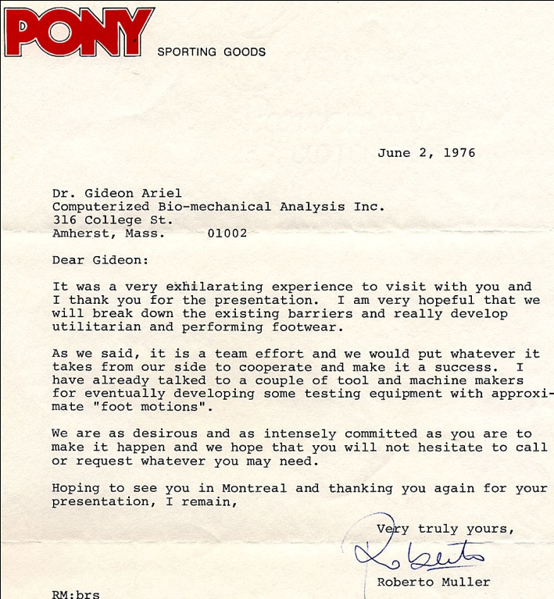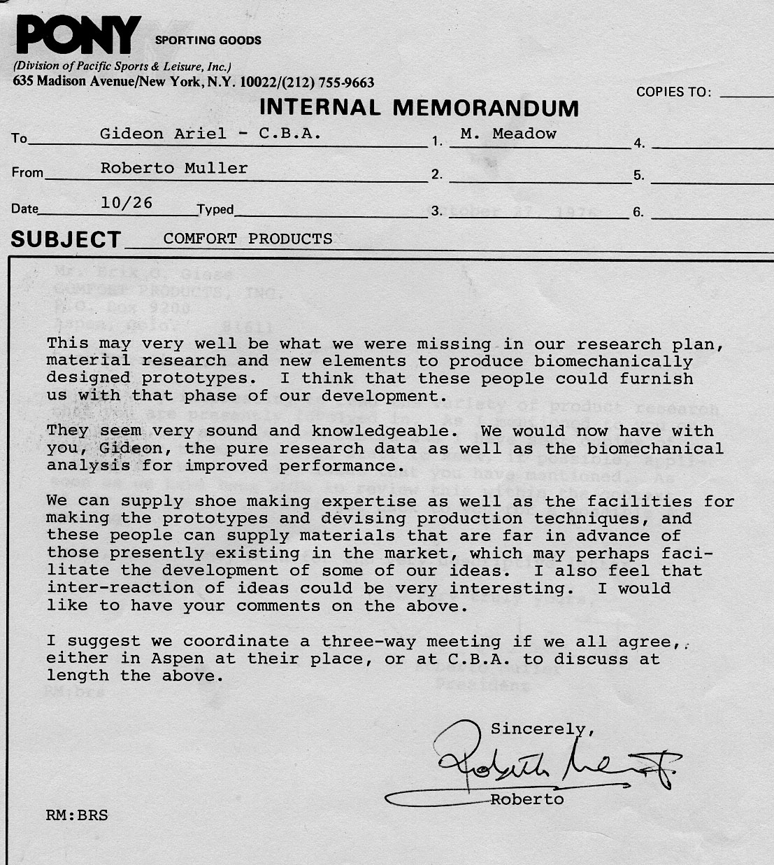
This long relationship with Pony and CITC started a number of large projects associated with the design of new shoes. Our first research was: “The Athlete in the Shoe.” It consisted of a:
- Comparative study of existing Basketball shoes
- Comparative study of existing Tennis Shoes
- Research study leading to the design of optimal basketball shoes
- Research study leading to the design of optimal tennis shoes
This research for Pony and the CITC companies took place during 1975 to 1984. Thousands of pairs of shoes were supplied for testing to the CBA company. And hundreds of data collection sessions were conducted at our laboratory, at the Olympic Games and at National competitions. CBA had the best data in the world for shoe design.
In 1981, CITC contracted CBA to do additional research. They wanted us to construct baseball shoes, as well as walking shoes. In the meantime, CBA were to receive royalties on every shoe that was made. The contract read for 10 cents on every shoe CITC produced utilizing the CBA research. That amounted to millions of dollars which allowed us to purchase new equipment, including our own high power computer in our laboratory.
Besides making us economically profitable, our research with Pony and CITC gave us national notoriety in leading magazines across the field. Each article had to be approved by Pony and CITC so we would not reveal any secret data.
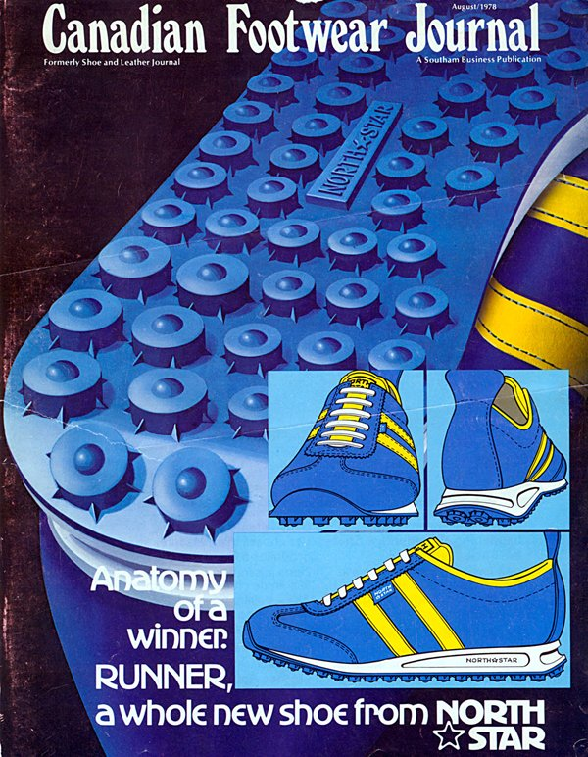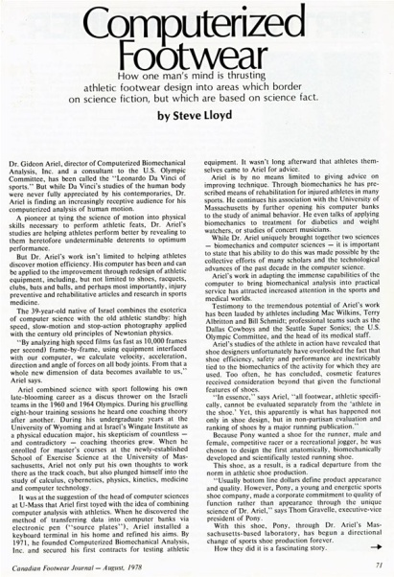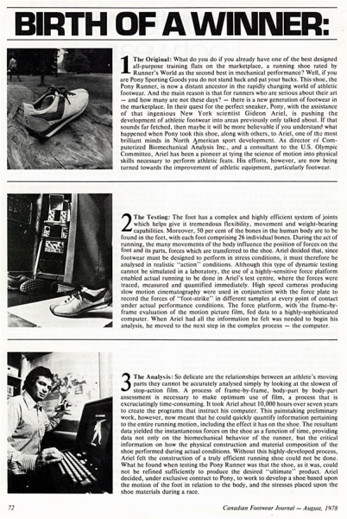
The article started with the following statement:
“How one man’s mind is thrusting athletic footwear design into areas which border on science fiction, but which are based on science fact.”
Now the phone did not stop ringing from companies looking to us for help in designing their shoes. One of many companies was the Brown Company in Boston, Massachusetts who wanted help with their nursing shoes. Our friends from Spalding in Massachusetts were manufacturing shoes also, and they asked us to help them develop athletic shoes. UniRoyal Company wanted help on their basketball shoes, and Dr. Scholl wanted some studies on their sole inserts.
Based on all the research that I conducted with shoes over those years, it became even more clear to me that athletes needed an Air Shoe -- a shoe that could adapt to forces and weights in various activities. So, since we had all the equipment for testing and so many manufacturers were working with us, I built the first Air Shoe.
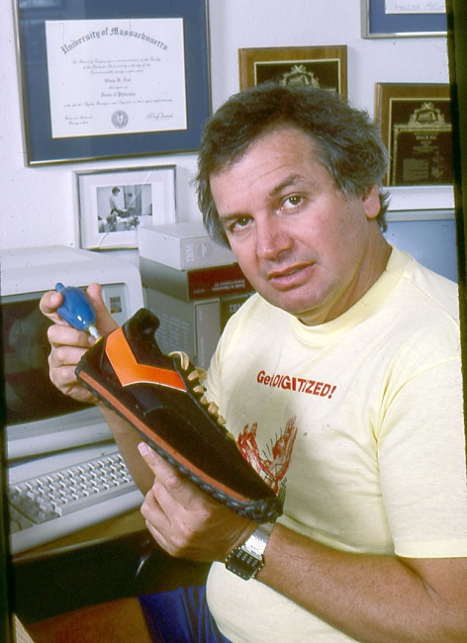
This was an inflatable shoe which could adapt to the pressure inside like a tire does on a car.
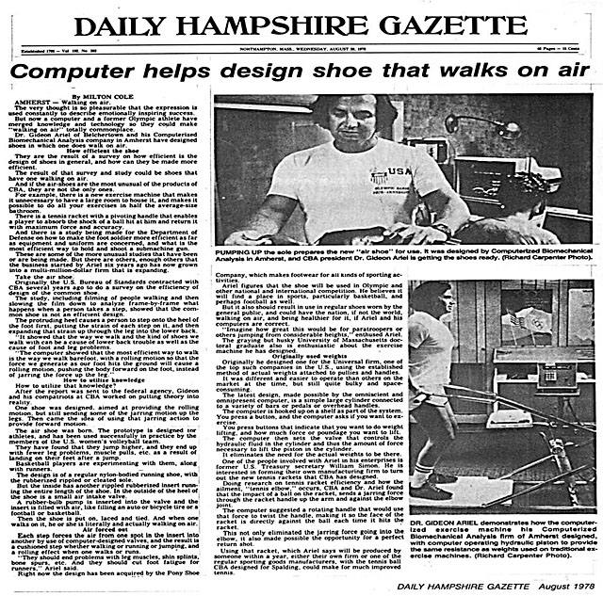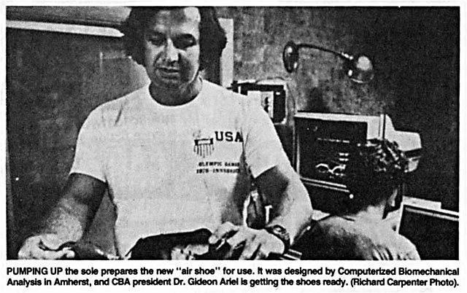
This invention was the first “Air Shoe” in the world. This was way before Nike came up with it or before Nike was even a company.
When the information came out in the papers, many people laughed. They would ask me, “Gideon, does that mean when you buy a jogging shoe you need to buy 3 in case you get a flat?”
Sports Illustrated came up with the following picture:
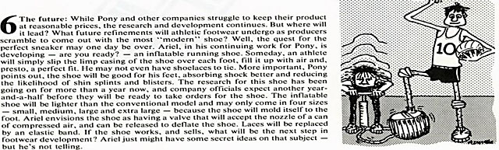
The inflatable shoe on the road…
However, Runners Magazine thought it was a good idea:
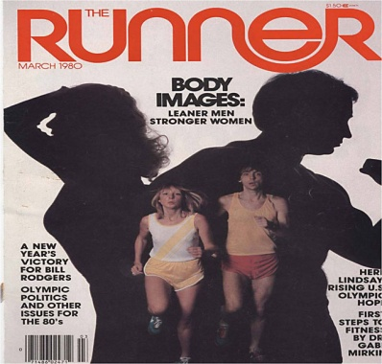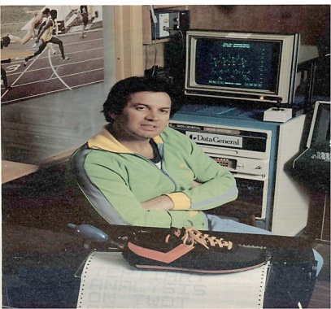
Runner magazine and the Inflatable Air Shoe
Some manufacturers were interested in producing these shoes for me. Here is one of the models:
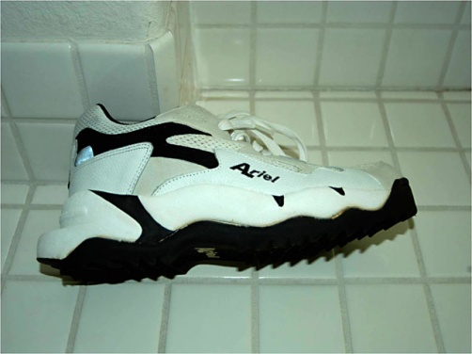
This was a great shoe, and it still is a great shoe. However, manufacturing it would cost more than it does for a normal shoe and business voted against it. So, the best shoe in the world died, as so many good ideas die, due to economic considerations. But I predict that, in the future, some company will decide to manufacture it.
But that didn’t stop many of the shoes we created being instrumental in helping people achieve their world records. I will mention only a few of our special shoes that were designed for this purpose.
Mac Wilkins, the discus thrower, came to our office in Amherst. You can see him in the next photo perform the discus throw movement in our lab, utilizing two force plates and our photographic, as well as EMG, equipment.
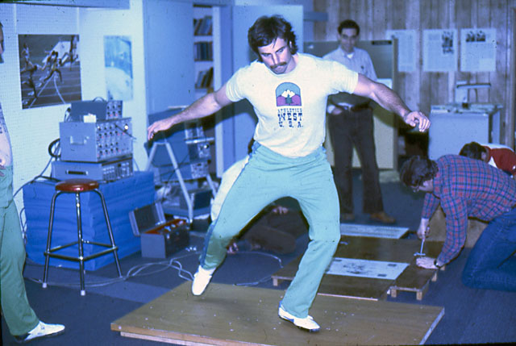
In the discus throw, the athlete turns over 360 degrees. That means that the rotational friction of the shoe sole on the rotating leg, which in the case of Mac is the left leg, should be minimal. However, just before the release of the discus, you do not want the athlete to slide forward or backward, since this will create a loss of energy that the athlete needs for exertion with the discus.
Therefore, we designed a shoe that would do just that, as one can see in the next photo.
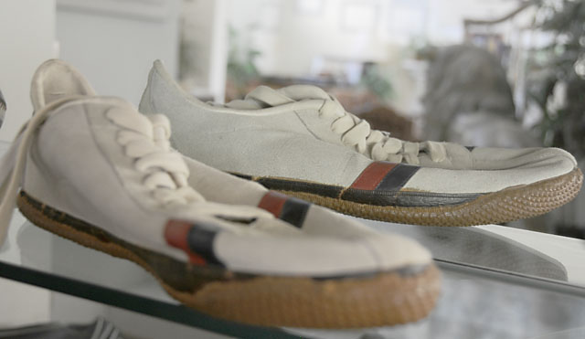
One can observe the small dimples on the sole which provides minimal rotational friction but holds the foot solid on the ground and stops any sliding forward and backward. This shoe contributed to Max’s world record in the discus.
Another shoe we designed based on the Pony data was a sprint shoe. By elevating the bottom of the sole toward the heel, we could save a few milliseconds on each stride. On a 100 Meters sprint, this would allow around a 300 millisecond advantage. In the next photo you see this design.

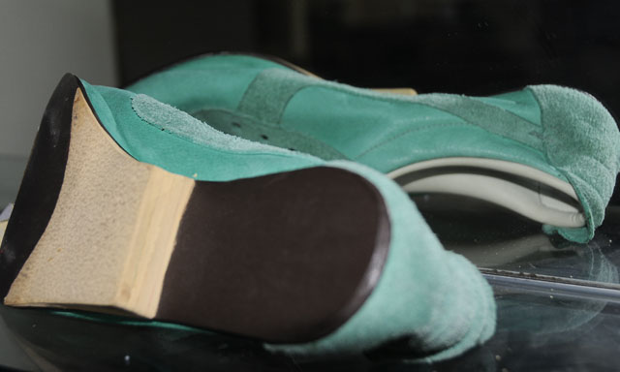
A sprint shoe that improves the speed of the athlete.
For sports that need cleats and other traction devices, we used our technology to create shoes with the optimal location for the cleats and nails. These were long jump shoes, high jump shoes, baseball shoes and golf shoes. The following shoe is one of them.
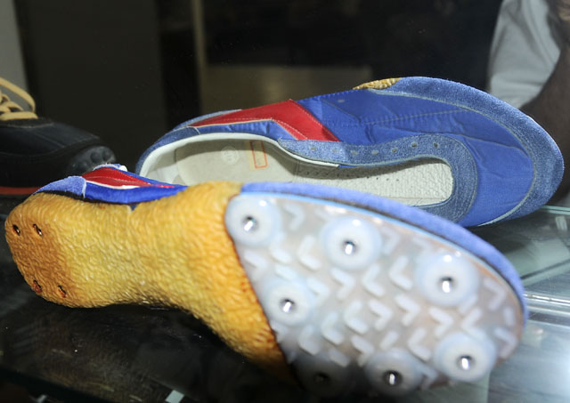
Shoes where the nail locations were optimized for the particular sport
The most popular shoe that Pony developed, based on our research and ideas, was the jogging shoe with the “Variable Sole.” We made a special sole where the shoe absorbed some of the shock when hitting the ground. In addition, when the foot was rolling toward the push phase, the sole had a different design to ensure good traction on the ground with less shock absorption.
The following photo shows the jogging shoe with the Variable Sole design.
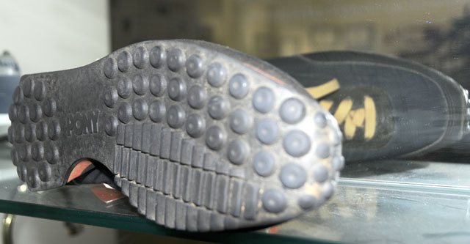
The Variable Sole design shoe
Next we heard from a baseball team, the Kansas City Royals. Besides wanting to talk about the Pony special shoes for their players, they asked me to analyze the proficiency of some of their best pitchers. This was only one study of many but I will present it here in some detail since many of the studies for other teams such as the Texas Rangers, Yankees, and others in baseball and football all basically follow the same procedures.
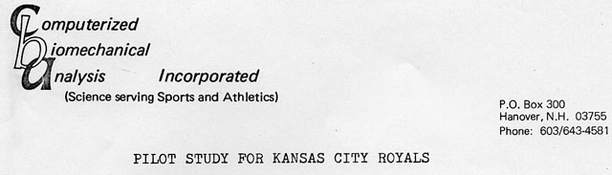
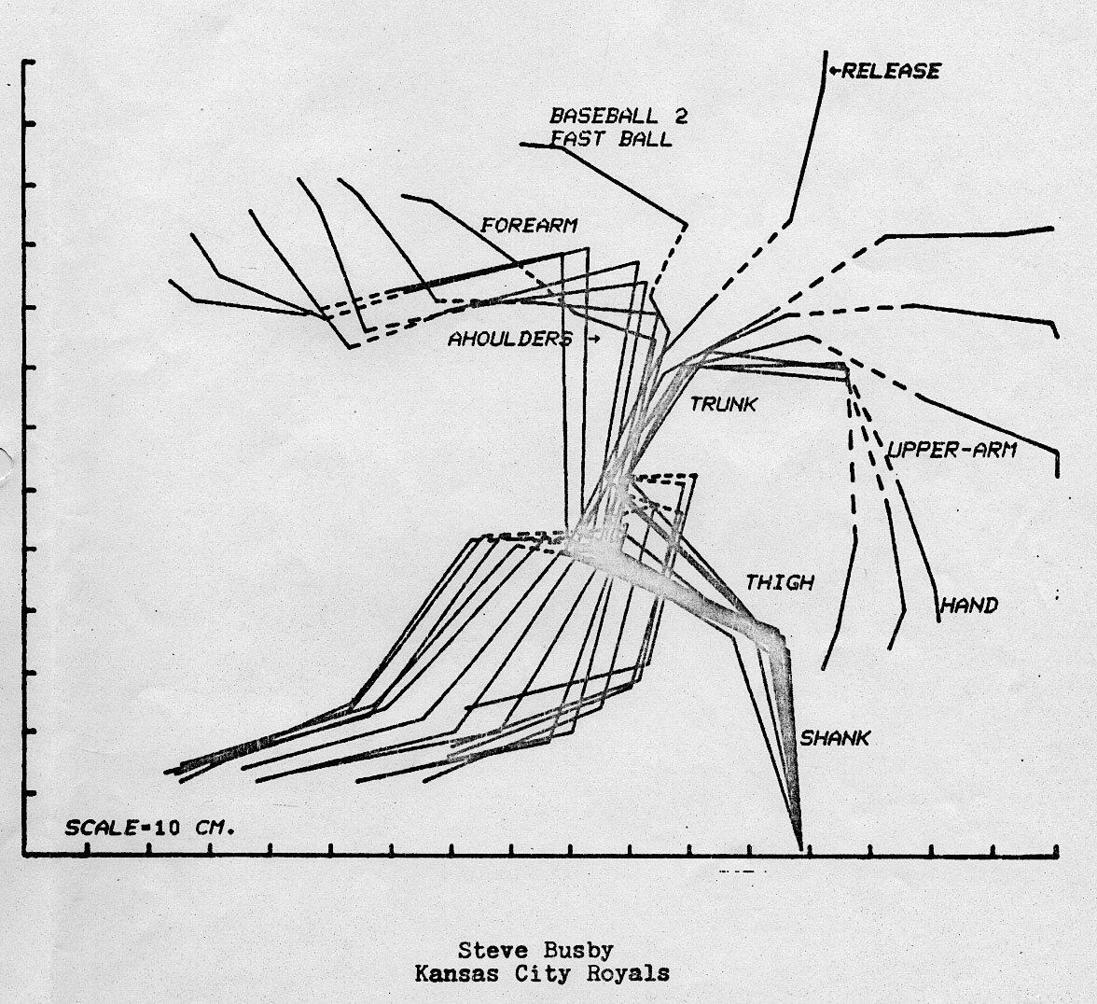

In this study we focused our attention primarily on comparing Steve Busby’s, a pitcher for the Kansas City Royals, and Doug Bird’s, another Kansas City Royal pitcher, patterns of motion in throwing a fastball and curve ball. Our data was based on photographing, at 64 frames per second, their performance against the New York Yankees in New York City, July 14, 1973.
Here’s what we saw: Busby demonstrated an extremely good pattern of using his body segments efficiently. Bird was also efficient but did not use his link system as well. Busby’s front shank and thigh decelerated abruptly just at the release of the ball contributing to the speed of the hand and ball. Bird had the same deceleration, but of lesser magnitude. This was because his deceleration was not as abrupt at release, resulting in a less efficient pattern of release. Busby used the knee extensors throughout the throw. He used his front leg to good effect. However, he tended to lose his thrust just before the release, when delivering his fastball. Bird used his knee extensors only partially. And although he used his front leg efficiently, it was not to the same extent as Busby.
We concluded that the magnitude of the elbow extension differences indicated that Busby was the stronger man. Bird needed to improve his upper body segments to increase the velocity of his throwing hand. Busby’s throwing sequence was almost perfect. He used his front leg to maximum potential. He was 25% stronger than Bird in the force of the direction of his throw. Bird needed to strengthen his body to achieve a stronger throw.
Now these two men really knew how their body worked when in motion.
At about this time, I was now invited to the United States Department of Commerce which is a department of the National Bureau of Standards, to speak about our methods of measuring human performance in sports, in industry and in normal life styles.
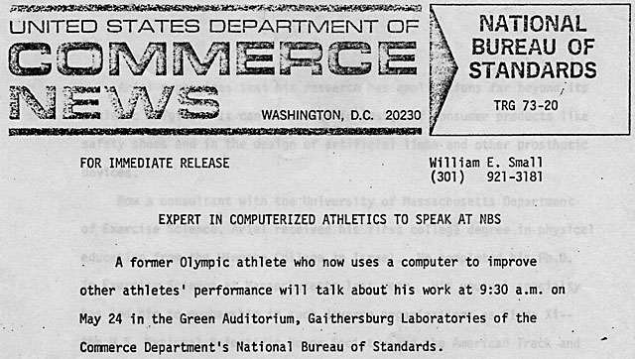
R. D. Jablonsky, Chairman
Task Force Committee D-21-06-06 1829 North Pepper Drive
Altadena, California 91001
May 7, 1975
Mr. Gideon Ariel
University of Massachusetts Amherst, Massachusetts
Dear Mr. Ariel:
As an outcome of the work on the measurement of slip resistance of floor finishes which has been pursued by ASTM Committee D-21, a Task Force (D-21-06-06) has been formed for the purpose of establishing a testing procedure for making
measurements in the field of slip resistance of floor surfaces. Test procedure D2047, using the James Machine, is a laboratory procedure. It is a goal of this Task Force to establish a testing method which will meet the following criteria:
- Provide reproducible results in the measurement of slip resistance of floor surfaces in accordance with ASTM policies;
- Be adaptable to a wide variety of
floor surfaces such as can be expected
in commercial and residential establishments;
- The results of the test procedure designed for field measurements be correlatable to the results of ASTM D2047; and
- The testing procedure and related testing equipment be practical and economically feasible.

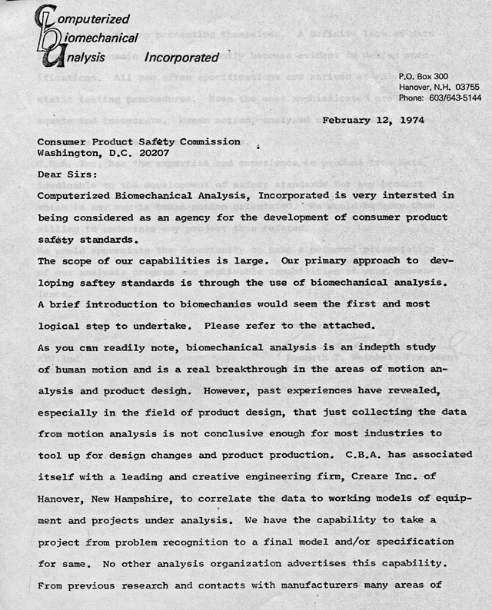
Besides being a great honor, there was something else that was special about this. My father, for the first time, came to visit us.
I remember Ann and I picking him up at the airport in our camper, and taking him to our lakeside home. He loved the beauty of it. He was a quiet, simple man, a bit overwhelmed by all that had transpired with his son. Maybe all my graphical work had something in common with his artistic eye. Maybe the precision was the same. Who was this man he had spawned?
He did not know what to make of CBA but he could see I was a PHD, teaching, and many articles had been written about me. It was all surprising to him. I do not know if he was proud or frightened, since he said nothing. But Ann and I did our best to make him comfortable.
I decided to take him to Washington D.C. with me and invited him to attend the presentation. We stayed at the Hyatt Hotel, a 5 star hotel down town. After dinner we returned to our rooms. I had a room with Ann and my father had his own room next to us. In the morning I went to his room and knocked on the door. The door was not locked so I opened the door and found my father seated on one of the beds dressed as he was the night before.
I asked him: “Father, how did you sleep?”
“I did not sleep.”
“What? Why?”
“Well he did not show up,” he said to me.
“Who did not show up?” I asked.
“The other person.”
“What other person, what are you talking about?” I asked.
He pointed to the other bed. Each room had two beds and he could not believe that he was in a room alone. In his mind, this was a waste of a bed. Poor father, he still lived in old Poland. He had never been in a 5 star hotel and never experienced a room with two beds by himself. Well, not surprisingly, he was quite tired that day. The next day we went to the Smithsonian, and he loved that. Years later when I visited him in Israel in his apartment, the neighbors told me that he told them upon his return to Israel: “You would not believe it, but my Gideon talked to the US Government. This is okay, but I cannot believe it; they listen to him…”
After the presentation, we were asked by the National Bureau of Standards to help with some unusual biomechanical studies. One was to change the design of matches so they would have a hard area below the ignite zone. In this way, matches would not break upon striking and burn fingers or cause fire. Then we got another strange (but practical) assignment. Could we study the biomechanics of a ketchup bottle?
We did study the Ketchup bottle and found that when a person takes a glass bottle from the refrigerator, the bottle is condensate. The danger is that when a person starts shaking the bottle so the ketchup will pour out, the bottle can “fly” out of a hand and hurt a baby or someone nearby. So, why not use a plastic bottle? A double blind study we performed yielded that, regardless of the brand of Ketchup, it always tastes better from a glass bottle. Obviously, a psychological factor. However, we recommended to make the mouth of the bottle wider so that the shake to get the ketchup would not have to be so aggressive.
Now I received a call asking me if my company could analyze changes in contours. The person identified herself from Kimberly Clark in Nina, Wisconsin. I told her that we could measure any 3D device whether it was a human or an object.
“Can you measure the contour of a noise?” she asked.
I told her that we could try. So, she decided to come visit with us. Her name was Elaine Jeville. Once we met her in Amherst , she told us she had been referring to measurements of changes in couture and reason for leaks in menstrual pads and Baby Diapers. Alright. Forward.

C.B.A., Inc. March 20, 1979
316 College Street
Amherst, Massachusetts 01002
Attention: Ms. Ann Penny
Dear Ms. Penny
Subject: Biomechanical Computer Analysis of Baby Movement
Kimberly-Clark Corporation would like to explore the possibility of doing biomechanical computer analysis of body movement.
We therefore want to investigate the contribution C.B.A., Incorporated, can make to our research. It is our intention to become involved in this type of analytical work for the reasons stated above.
Introduction
The following research project to study to establish experimental techniques for evaluating the fit and improving the performance of menstrual pads for the Kimberly-Clark Company. The research focused on two independent techniques. First, a computerized, three-dimensional, photometric technique was developed to determine pad surface contours before and after being worn. This permitted quantification of pad distortions resulting from wear as well as computer-generated graphic representations of pad surfaces. Second, an electronic pressure transducer was placed within the middle layers of the pad. This device was used to record internal pad pressures generated during the performance of a variety of activities.
Since the purpose of this study was to demonstrate the development of technique, particular emphasis will be given to an explanation of methods devised and details of their implementation. For this study, multiple trials on a small sample were utilized both for measuring pressure and generating three-dimensional surfaces for two different pad types under two experimental conditions -- before and after wearing. The first pad, referred to as Pad A was a New Freedom Maxi pad. The second pad, labeled as Pad B, was a New Freedom Mini pad.
Three-dimensional surfaces
Method:
The three dimensional (3-D) surface coordinates for a pad were computed using a direct linear transformation technique. This procedure involved photographing a pad from several angles such that included with the field of view was a set of points having accurately known 3-D coordinates. The known coordinates, referred to as test points, are used to "calibrate" the field of view. Coefficients are calculated based on the test point information and are used to compute the 3-D coordinates of all the pad surface points. This is the linear transformation.
While extensive mathematical manipulations are required, it can be demonstrated that only two different views in the field of six known test points are necessary in order to compute the 3-D coordinates of an object. The test point array consisted of a specially machined apparatus with posts of varying height surrounding the area where the pad was placed. Engraved markings were machined onto the top of of each post and at the grid intersection
wearing. The first pad, referred to as Pad A was a New Freedom Maxi pad. The second pad, labeled as Pad B, was a New Freedom Mini pad.
Three-dimensional surfaces
Method:
The three dimensional (3-D) surface coordinates for a pad were computed using a direct linear transformation technique. This procedure involved photographing a pad from several angles such that included with the field of view was a set of points having accurately known 3-D coordinates. The known coordinates, referred to as test points, are used to "calibrate" the field of view. Coefficients are calculated based on the test point information and are used to compute the 3-D coordinates of all the pad surface points. This is the linear transformation.
While extensive mathematical manipulations are required, it can be demonstrated that only two different views in the field of six known test points are necessary in order to compute the 3-D coordinates of an object. A flow diagram illustrating this technique is shown in Figure 1.
The test point array consisted of a specially machined apparatus with posts of varying height surrounding the area where the pad was placed. Engraved markings were machined onto the top of of each post and at the grid intersection
points. The location of these points and intersections are known to within one thousandth of an inch. Points lying in close proximity to the pad area were chosen as test points. Thirteen test points were utilized since this larger number enhanced the accuracy in the 3-D calculations as well as allowed for consistency testing of the data. Figure 2 shows the test point field. The 3-D coordinates for these test points are shown in Table 1.
Each pad was marked with a numbered grid. The numbered grid of points were located at one-half inch intervals on the top surface of each pad, as shown in Figure 3. The 3-D data point coordinates were then calculated for each of these points according to the following procedure.
In order to determine the 3-D pad surface profile, the numbered pad was placed on the specially machined apparatus within the field of the test points. Photographs were then made from a minimum of four views. For the present study, photographs were taken during each testing sequence with four views of the pad before it was worn and five views taken after use. The decision to utilize more than two views was to enhance the accuracy of the 3-D determination and to insure that each point on the pad was visable in at least the minimum number of required views. A Cannon 35mm camera with Panatomic-X black and white film was used for the data collection. Figures 4 and 5 show Pad A from two views before use and Figures 5 and 7 show the same pad after Following the photographic data collection phase, each view was projected onto a digitizer screen. The two-dimensional coordinates of each test and pad point were determined using a sonic digitizer. These coordinates were electronically transmitted to a computer and stored for later processing. Figure 8 shows Pad B during the digitization process.
At this stage in the process, all information needed for computation of the 3-D coordinates for the pad resided in computer memory. A series of computer programs then calculated the coordinates from the digitized pad and test point data. From the digitized test point data and the known positions of the test points, the linear transformation coefficients were determined. The linear transformation was then used to calculate 3-D coordinates for the pad surface points. The 3-D coordinates were stored in the computer for subsequent processing.
With 3-D coordinates of the pad points known, various properties of the pad were quantified. Appropriate computer programs calculated the following properties for each test pad:
- Length
- Minimum and maximum width
- Average width
- Minimum and maximum height
- Average height

We hired 30 lady volunteers who received payment to conduct the experiment.
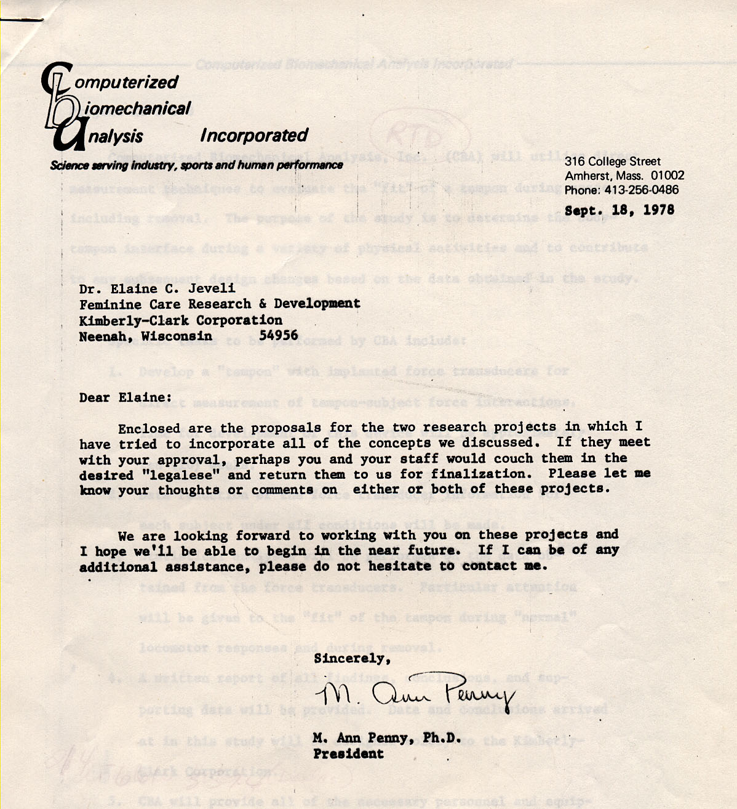

We designed a special calibration frame to set the pad on and calculated the measurement at all angles from each coordinate.
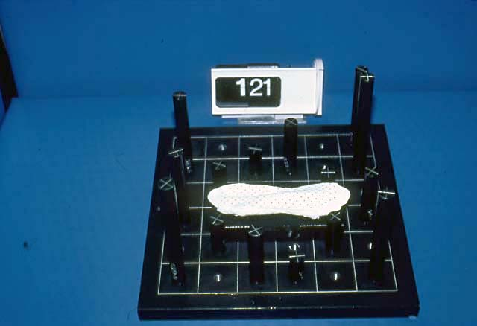
Couture measurement of pads
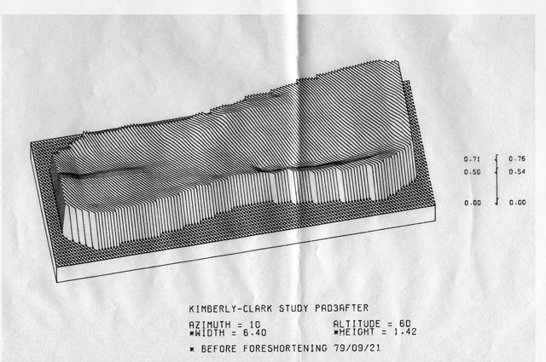
Computer Graphic output of Various Shapes of the Pads
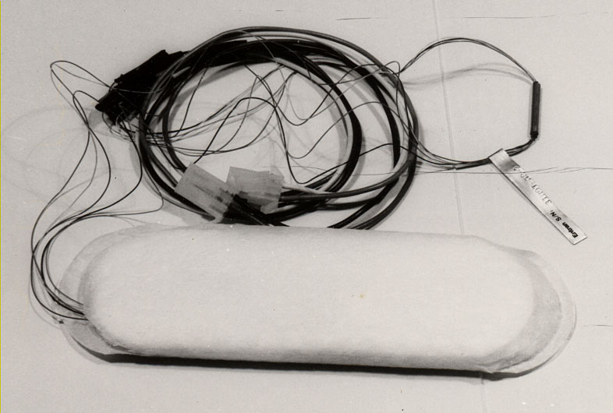
Pads instrumented with micro load censors to measure pressures inside the pads
We found that in the process of sitting and standing up, pressure differences and a slight vacuum caused the pads to leak. Obviously, Ann conducted this study in its entirety. But, people walking along Route 9 during the day did not know what to make of 30 ladies walking with wires coming out of their pants. We also set mini transducers inside the pads to measure forces.

By this time, in 1975, CBA Inc. could afford to purchase almost any technology we needed to improve our methods of analysis. We purchased new digitizers which were more sophisticated than the first digitizer which I had invented. Also, we purchased more force plates, EMG equipment and faster terminals with storage capabilities. At that time the 5MB disk was a huge plate that cost around $10,000. The Analog to Digital converter board for the Data General computer was 15 inches square and cost around $25,000. We also purchased the Megatek Equipment which allowed us to convert data to 3D display with hardware hard wired so it was almost in real time. This Megatek cost us around $150,000. By then, with all this equipment ,we were the most advanced Biomechanical corporation in the world, which was easy since, in fact, we were the only biomechanical company in the world.
Some University laboratories, such as at Penn State, had minimal equipment. But they were not really competition. The CBA equipment was a show place to any organization that was thinking of expanding their motion analysis capabilities.
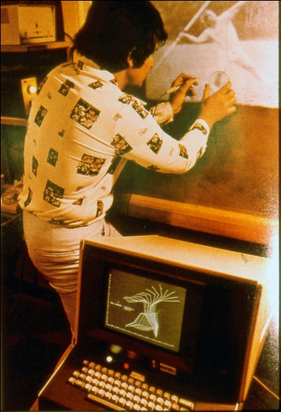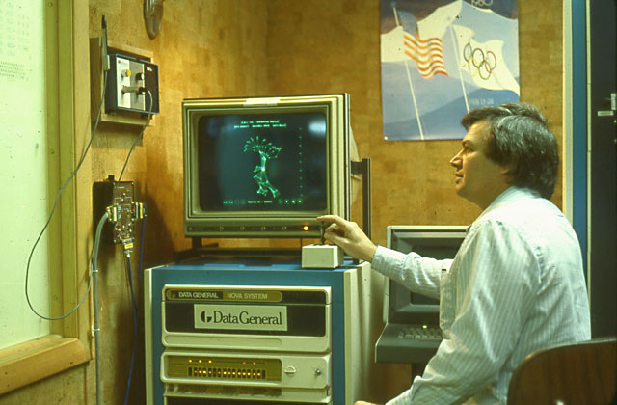
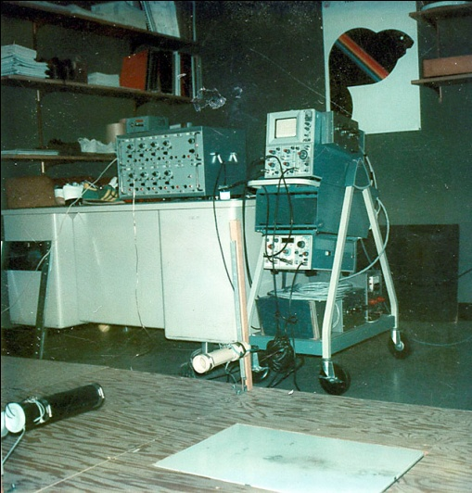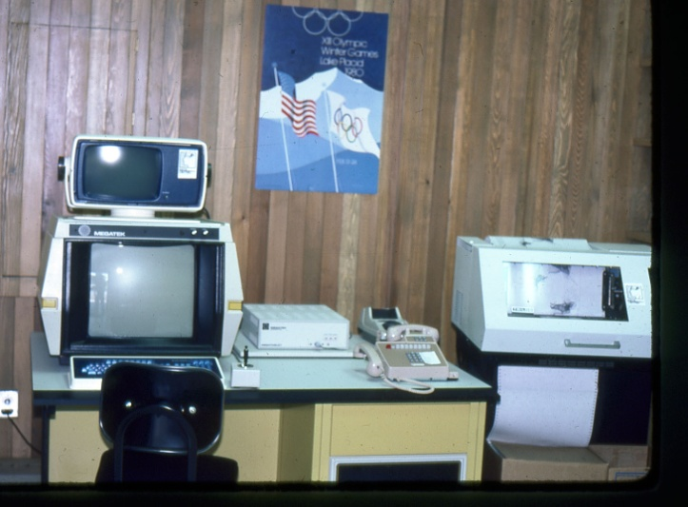
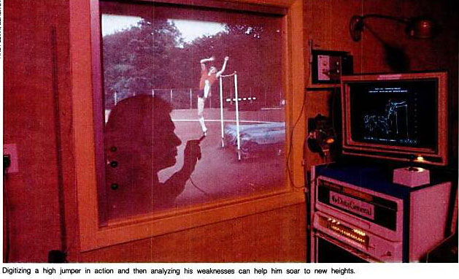
Some of our new Computer and Electronic Equipment
In 1976, I received a call from our old friend at Spalding, congratulating me on our new equipment. He wanted to meet so we set a time. During our discussion, he told me he wanted to conduct a major project on the analysis of tennis balls. There were so many questions about what happens to tennis balls in a game. How long does the tennis ball remain in contact with the racket and how long does it stay on the ground? What is the loss of velocity between the impact with a racket and the velocity when the ball hits the opposing racket? What is the coefficient of friction with the ground and a variety of surfaces? And, how does the Spalding ball compare with their competition?
This was a huge project which required our building special equipment, such as a ball throwing machine, and sensors to detect the movement of the ball. The plan was that after reviewing our initial results, Spalding would design a new tennis ball with the data that we acquired. Then we would investigate if the newly designed Spalding tennis balls had favorable characteristics compared with other brands of tennis balls. Some of the other companies which we compared the Spalding tennis balls to were Wilson Sporting Goods, Penn, Dunlop and Tretorn. Spalding supplied us with hundreds of every kind of ball.
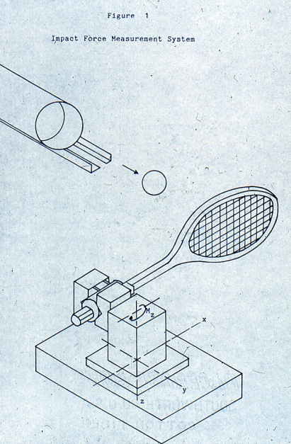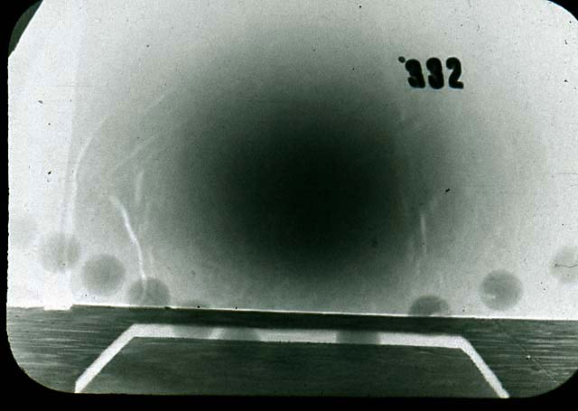
Computer control Throwing Machine and 10,000 frames per second Photo
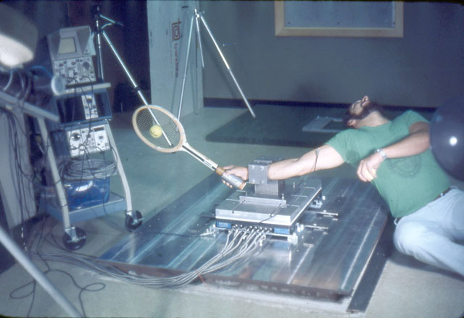
Tennis Ball, racket, and human interaction
Thousands and thousands of shots were taken and stored in our computer.
From previous projects we had conducted for Spalding, it was determined that “faster” or “livelier” tennis balls are not necessarily more desirable for the tennis game. It seems that a tennis ball which maintains longer residence time on the tennis racquet is easier to control. At the same time, a longer flight time after rebounding from the surface will enable the player more time to react to the shot. With this criterion in mind, Spalding designed a new ball with different internal pressure.
Some of the parameters that were measured and changed for the new tennis balls were Angle of Approach effects on the ball. In addition, we measured the velocity of approach, the rebound angle, the rebound velocity, the coefficient of restitution which is the ration of the velocity of approach to the velocity of the rebound. Also, we studied kinetic measurements of the forces, moments, holding time, momentum and friction.
Here’s what we learned:
The hardness of the tennis ball is an important component of its behavior. Playing surfaces significantly affect the behavioral characteristics of the tennis balls. Based on our studies, Spalding designed a new tennis ball with specific characteristics and gave us royalties of one cent on each ball that sold. There were millions of balls.
Our newly designed Tennis Ball for Spalding
Working on all these projects with a staff of 5 and at least 20 students to help us made us very efficient. My joint appointment at the Exercise Science Department and the Computer and Information Department gave me access to “brain power.” If I needed any help in the area of engineering or computer software development, I would have it instantly.
For example, while I was working and teaching, I also took courses, as I have mentioned before. I decided to take all the basic engineering courses that consisted of Static, Dynamics, Strength of Material, and Hydraulics. As pre requisites I had to also take all the undergraduate courses in Physics. My professor in Physics was Dr. Paul Tartaglio. Professor Tartaglio assigned the class some physics problems as a regular assignment. Instead of using a slide rule and paper and pencil, I wrote a program on my computer terminal in a simple BASIC language. When I submitted the assignment on a yellow role of paper which the terminal had outputted, Professor Tartaglio called me to him.
“This is cheating,” he said.
I explained to him that to write the program for each problem takes more time and understanding of the problem then just to follow some rule of computation. I invited him to my CBA lab, and he was impressed and found out, as Professor Story found before, that I already had my Ph.D. He became a sort of friend from then on, and at the point where I needed to construct the Cam for the Universal Gym Company, I hired Paul to work for me. He became my engineer while continuing to teach at the University.
One of the reasons Professor Arbib had hired me into his department was our ability to conduct research which helped him obtain large grants, based on the equipment that I had in my laboratory. One of the larger grants, that amounted to a total of $700,000 for the University of Massachusetts, dealt with the field of Cybernetics.
Their proposal was dedicated to studying the logic of movement, related to the nerves in the cerebellum. They requested funding from the National Science Foundation to extend their study on two fronts: first by setting up a computer graphics simulation of the spinal circuitry involved in reflex movements and locomotion; and secondly, to provide experimental data on the biomechanics of movement by computer analysis of cinematographic records.
The Department of Computer Sciences under the Chairmanship of Dr. Arbib received multiple grants which led to amazing research studies, thanks to our equipment. By the way, CBA never charged any money for the use of our equipment. I did it as my contribution to my responsibility as an Assistant Professor in the department of Computer Sciences. I did use some of the research toward achieving another Ph.D. degree in Computer and Information Sciences and I was considered as a Post Doctoral student in the department, in addition to my professorship.
But our most unruly research study was about to begin. Two professors at the Department of Computer Sciences were Dr. Niko Spinali and Dr. Kilmar. They had both taught Ann and me.
Dr. Spinali’s research, with our equipment, involved 3 groups of cats. One group was blind folded from the day they were born. The other group had one of their eyes covered with a vertical slit, so they could see only through a vertical cut, and the other eye was covered with a horizontal slit, so they could see from this eye only. The third group of cats were the control group which were normal. First, we let the cats grow to a few months old, feeding them well and exercising them on a mechanical treadmill. The cats, unfortunately, were going to have brain surgery, and their visual cortex cells were examined under the microscope.
What the researchers found was most surprising. The visual cortex cells showed vertical and horizontal arrangements at the opposite side of the visual cortex. One of the explanations was that our experiences really do create physical templates in our brain.
Now we were to analyze the initiation of coordinated limbs in walking and running cats. Why does the cat move faster in a fast walk as compared to a slow run?
Here is the logic for doing such an experiment:
The ultimate goal of the present research may be described as an attempt to formalize a logic of movement which is computerized and anatomically faithful. The work thus far has provided a plausible model of the role of the cerebellum in such a scheme. The strategy of this model is based on the Bernstein theory which advocates that movement be analyzed in terms of synergies, i.e., movement is the result of standard patterns of coactivation of muscle groups rather than independent activation of particular motor units. This cerebellar model contains the neural circuitry for the generation of synergies; it is assumed that these generators operate continuously and that they are selected and switched into spinal mechanisms at the appropriate time.
It is now necessary to analyze in detail these spinal mechanisms and the method by which they recieve the synergistic programs, with the hope of constructing a model which can be interfaced with the cerebellum model. The particular aspect of movement which is to be emphasized is locomotion in the cat, since the locomotor algorithm is known to be resident spinally. Two specific results toward which this investigation is aimed are: 1) a mathematical description of the various gaits and changes of gait; and 2) the ontological development of locomotion from six weeks to adult. The unique facilities available enable the approach to these questions to be experimental, biomechanical and cybernetic. Thus the model will take into account kinematic and kinetic data gathered from normal and spinal cats.
II. EXPERIMENTAL METHODS
The data are gathered by employing slow motion cinematography in conjunction with a treadmill and a force plate. Analysis of the data is accomplished by using a computer digitizer complex, a display terminal and hard copy unit, and a graphics plotter, all interfaced with a CDC Cyber 74 computer.
The treadmill is meters long and is equipped with a continuum of speeds ranging from 0 tocm/sec. The speed can be set to any constant within this range or can be varied continuously while the treadmill is in motion. The unusually long treadmill enables the cat's locomotion to be observed and compared in several distinct ways: 1) the cat can move freely along a still treadmill thus totally determining her speed and gait; 2) the treadmill can be set to a constant speed and the cat can move freely along it and adopt a speed which is less than, equal to, or greater than that of the treadmill; 3) the treadmill can be operated with varying speeds and accelerations and the cat can adapt to the treadmill's speed and accelerations or determine her own; 4) the cat can be harnessed in place and forced to adapt the speed and acceleration of the treadmill. It is important to observe that in the first three cases, there are no external devices attached to the cat and no abnormal confinements placed on her locomotion. Her inducement to move is simply her desire to reach a cage placed at the end of the treadmill.
Additional data are collected by inducing the cat to walk across a force plate toward food at the opposite end. multi-component measuring platform, type 9261A, made by Kistler corporation is used to record forces for the cat's locomotion on the floor. While moving forward, the cat steps on the force plate which is at floor level. The force plate measures the three components (Fx, Fy' Fz) of the force exerted by the cat's legs. The instantaneous point of force application as well as the moment about a vertical axis can be determined. The measuring platform is based on four three-component quartz measuring elements which are highly compressed and are mounted between the base and the top plate. The forces are measured with virtually no deflec tions; proportional charges appear on the plate output connectors. Eight outputs are connected to a charge amplifier, type 5001, which transforms the electrical charge obtained from the platform into an analogue voltage. Special summing amplifier units are used for measuring moments and determining the point of force application. More detailed information on the biomechanic force plate and its charge amplifier can be obtained from the Kistler Corporation. The type 9803 multi-channel amplifier assembly is used with the type 9261A.
The results showed some principles in the neural control of locomotion in cats. This gave us information on how the brain controls our movement when we are walking and running.
This study was written about in the following publication:
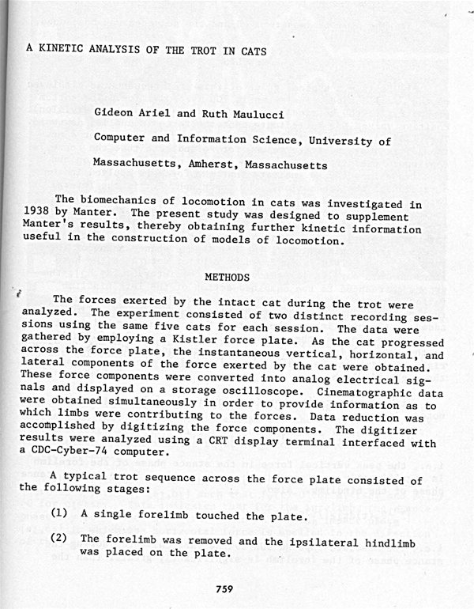

In one of the experiments Ann and Ruti Malucci were in charge of, we were supposed to de- cerebrate the cats after the experiment in order to measure the movement of the legs with no higher center brain control. The cats would only have what the neurological guys call a “spinal generator.” This was part one of the grant from the N.I.H (National Institute of Health) in Washington D.C. Well there is no way in the world that Ann could allow a cat to die.
What I heard her say was, “If these were human subjects, then I would not care, but not cats. These cats already gave their lives to science, they do not have to die for science.”
So, we had to modify the testing procedures. I suggested that instead of mutilating the cats, we would restrict the movement of the cat’s head by having them wear a harness, so the cats could not see the ground while they ran. We could then compare normal to restricted behavior , and show the adaptation of the nervous system to their experience as they ran forward at different heights. After a number of meetings with Dr. Arbib, he agreed to this plan.
My next challenge was to convince the N.I.H. that these procedures would allow us to collect more information than by using their more cruel method. Finally, they agreed too.
Now we had 25 cats whose limbs needed to be shaved so we could mark their joint centers with light sensors. Not an easy task! Then we began running them daily over a force plate toward food while filming them on high speed cameras. We digitized the film to calculate the velocity of their limbs and the coordination of each limb to the other, whether walking or running.
The days we set for our data collection were Saturdays since they were quieter days. Less people came into the office. However, one Saturday, it turned out we also had to collect data on a monkey’s jump. How did this come about? One of the scientists, his name was Dennis, came from the Anthropology department and was working on the locomotion of monkeys and wanted to measure the forces the monkey produces during a jump and how it affects the growth of their bone development. For this data collection session, we decided to put our 25 cats in the bathroom.
Dennis started running with a banana to try to motivate the monkey to run over the force plate and jump. It took hours to achieve, but finally the monkey jumped.
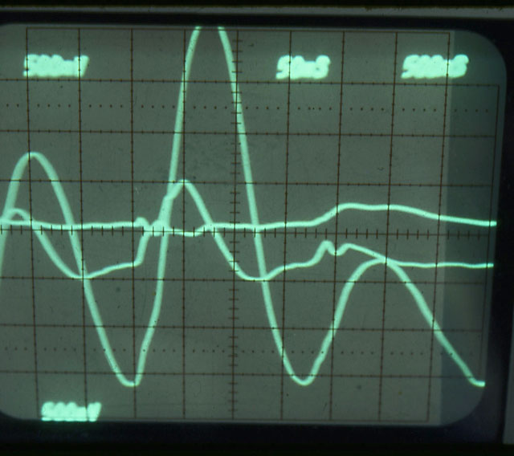
Monkey Jump Data on the Oscilloscope
Suddenly, our partner Larry opened the door. Normally he would never come in on a weekend. The first thing he saw was a strange man, Dennis, a burly guy himself, running around with a banana in his hand with a monkey chasing him. So, Larry excused himself and went to the bathroom. Upon opening the door, 25 cats ran out to the lab floor. The monkey got hysterical and started chasing the cats. The cats ran for their lives. Ann and I tried to catch the cats, Dennis tried to catch the monkey and Larry ran out to his car.
Years later when we met with Larry and his wife, he said, “Muriel, do you remember how I came home and immediately poured myself a few glasses of scotch? You asked me what happened, and I answered, Don’t ask, you will not believe it anyway.”
We collected our data, studies were published and now we had 25 beautiful cats with us. Ann and Ruti had to find homes for them. So part of the grant money was spent finding qualified homes for the 25 cats. In some cases, cats had to fly across the country to meet their new parents.
Mission accomplished. The University got their research done, Ruti received her Ph.D., Ann received credit toward her Ph.D. and I started to have more time for myself on Saturdays. Not to mention, the cats all had loving homes.
My association with the Cybernetics Department and working on the locomotion of felines resulted in me meeting many scientists in other disciplines. One discipline that never occurred to me to get involved with was the field of classical music. Even though I love classical music and listen to it in my lab while I am working, I was surprised to be approached by a very famous violinist by the name of Paul Zukofsky. He told me how much he wished I could become involved in his grant from Bell Laboratory to analyze violin playing.
Paul met me in my laboratory in Amherst and we discussed the study that he was conducting. He wanted to demonstrate the limits, correlations, and constraints on the cooperation of hands and arms when playing. We already could see that the technique analysis was not different than analyzing a Shot Putter or a Discus Thrower.
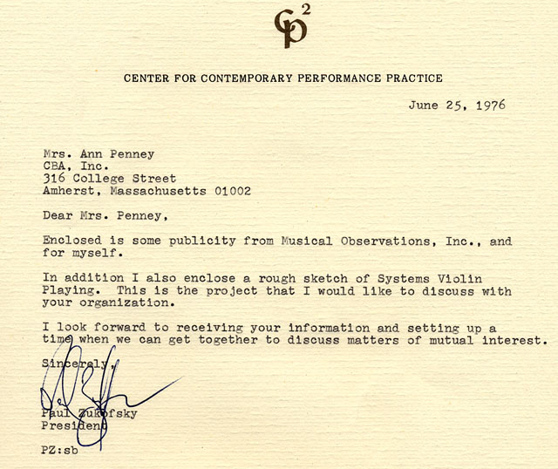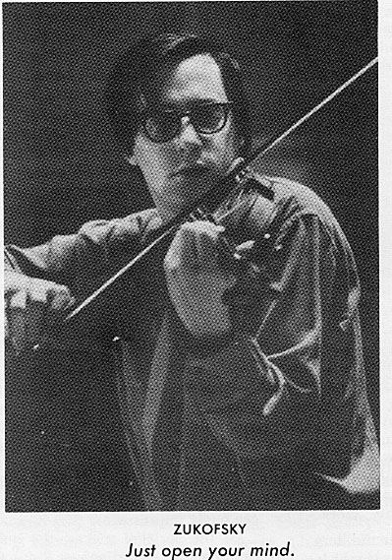
We had Mr. Zukofsky stand outside our laboratory facing Route 9 on a pedestal in his shorts, with his concert jacket on, to perform pn the Paganini. We needed him to play outside of our Lab since we were going to have to take high speed film from the front, side and above. We did not have enough space in the lab. Now the cars on Route 9 began stopping to watch the shoot. In fact, after a while the local police came and I had to explain to them what was going on and that I needed only a few more hours to complete our work.
The results were fascinating. For instance, we found that in traditional violin playing, the arm holding the violin must stay “fixed” and steady, while the arm and hand holding the bow does all the moving. This restricted motion makes some violinists not able to play certain notes of music. However, by using the “fixed arm” to help the bow hand by holding the violin back and forth at certain frequencies, it assists in executing difficult patterns of movement required in playing specific notes.
This violin study led to another “musical study,” this one involving the Harp.
Moving the fingers over the strings requires electrical signals to enervate the muscles of the various fingers. Biomechanically we could correlate the electrical signals with the movement of the fingers. Would it be possible to play the harp without the harp?
By collecting EMG (Electromyography) data and biomechanical data we could correlate the movement of the fingers with the particular musical notes.
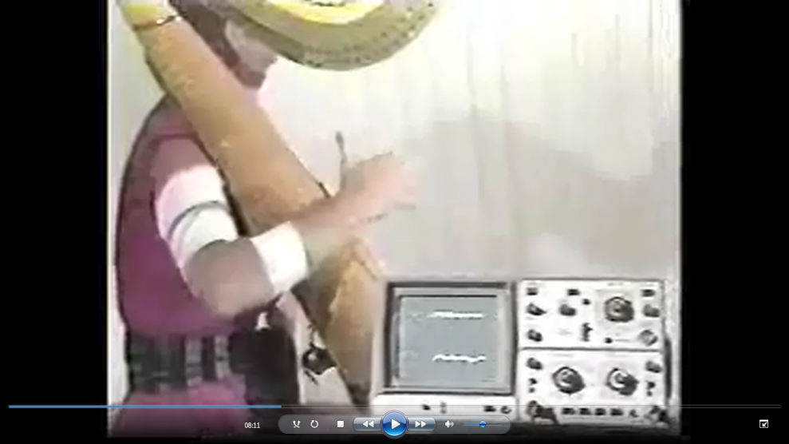
Collecting Biomechanical data and EMG data
The results were surprising. The harpist could play the particular music just by moving the fingers as if she touched the harp, but with no harp. These harp-playing movements sent signals to the computer which converted into exactly the precise sounds and notes. This study was published in one of the scientific journals.
One evening Ann and were at hour Lake home in Belchertown. I was working on some research report while Ann was cooking some dinner. Suddenly the phone rang in our house. I answered it and someone on the other end asked me if we can analyze football quarterback throwing arm. I was sure it was one of my student and I told him: “I will cover it tomorrow in class, please remind me to answer this question.” Well the person on the phone told me: “I am George Allen from the Red Skins”. “Are you some kind of a coach?” I asked him and at the same time, I whispered to Ann in very low voice: “Hay Ann, it is someone from some Red Skins, what the hell is that?” “What his name?” Ann asked. “Excuse me again what is your name please?” He told me and I told Ann, his name is George Allen. “What!!!!” “This is the head coach of the Washington Red Skin. You crazy? Talk to him.” Well, I apologized for not recognizing the great Man and told him that I have problem with my phone to understand his voice. He understood. He invited us to Washington D.C. and we did some work for the Red Skins. Especially analyze the QuarterBack.
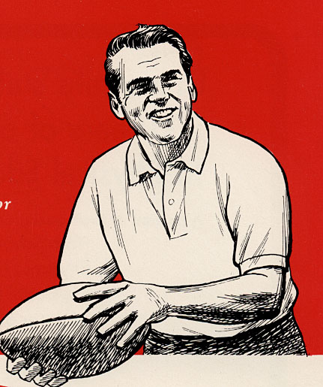
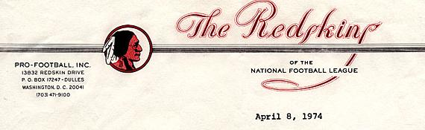
Dr. Gideon B. Ariel
Boyden Gym
University of Massachusetts Amherst,
Massachusetts, 01002
Dear Gideon:
Thank you for your recent letter sent to Bill Hickman. Enclosed is a check for your expenses submitted for your visit to Redskin Park.
Keep me informed if you have any other suggestions. We can take the time to go into a lot of facets of your program -- I am more interested in the things that I mentioned to you.
with best regards,
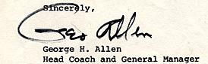

Another area that we got into was Workmen’s Liability and Insurance claims. Our Biomechanical System could evaluate injuries or fraud to a high degree of accuracy. Therefore C.B.A. got involved with a number of law suits, since our analyses were based on science, not guess and opinion. We began doing studies in these cases in the 1970’s and we are continuing to this date.

One of our most high profile cases was Johnny Carson (the famous TV personality) vs LNR Industries, manufacturers of gymnastic equipment. Mr. Carson contended that an injury to his neck and back – incurred while falling from an exercise slant board -- was a direct result of the slant board malfunctioning. Mr. Carson filed for $500,000 in damages against LNR Industries and their insurance carriers, who contracted CBA. We were to replicate the accident using a test subject the same size and weight of Mr. Carson, and photograph in high speed the identical exercises which Mr. Carson did.
What did we find? Our frame-by-frame analysis revealed that it was mechanically impossible for the slant board to malfunction under those circumstances. These findings were confirmed by an independent engineering firm, Truesdail Laboratories. Mr. Carson withdrew his legal suit. Our fee for the $500,000 damage suit was $4,200!
We were involved in another case where a novice gymnast was injured while attempting a back flip, resulting in total quadriplegia. A demand for $5 million in damages was based on the plaintiff’s contention that the substance of the gymnastic mat – ethafoam – was negligently manufactured by Dow Chemical Company, and that the ethafoam did not effectively prevent his injury.
Initially, Dow Chemical was ready to make a $1 million out of court settlement, strictly on sympathy, regardless of fault. However CBA revealed through our analysis that it was impossible for a substance to be both non-resilient enough to permit an individual to complete a back flip and resilient enough to absorb an injury of that kind. The case is still pending.
Presently, workmen’s compensation claims reach over $14 billion each year. To date, there has been no precise system to measure the degree of disability, and as a result, companies have resorted to general formulas to determine the amount of workmen’s compensation.
Using biomechanical analysis, the actual degree of a worker’s disability can be measured, within a very small margin of error.
The following is the detail of the Carson Case:
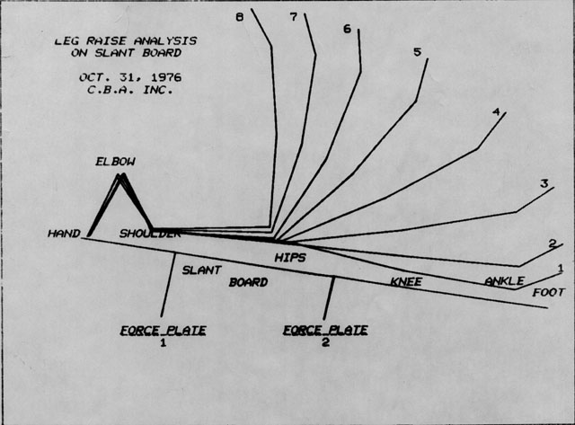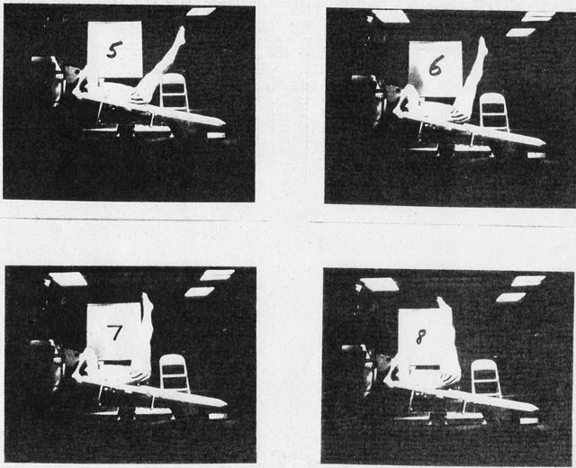
Slant Board analysis in the Carson Case
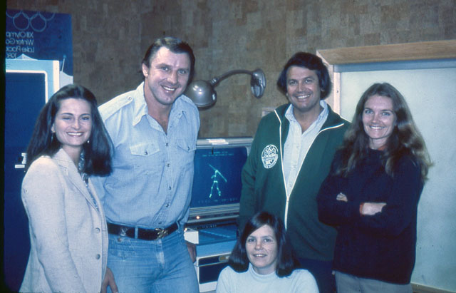 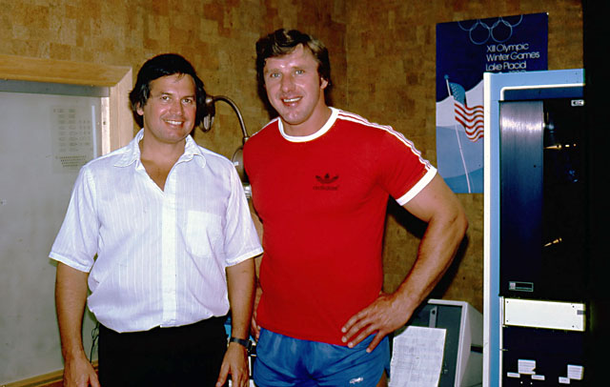
Al Oerter, Four times Gold Medalist in the Discus in our lab at Amherst
Al Oerter, my hero whose picture had been above my bed in Hadassim after he won his Helsinki medals in 1952, and Melbourne in 1956, and beat me in the Rome Olympics in 1960 and in the Tokyo Olympics in 1964, came to my lab. Can you imagine my excitement? Al came to get help at the age of 44 to try to improve his discus throw so he could make the 1980 Olympics in Moscow.
We worked hard together. I had shown him that even at 44, with his strength and speed, he could still break the World Record. Al, a computer engineer himself, watched himself on our screen and was able to see how much better he could perform. And he did. Unfortunately, President Carter boycotted the Olympics in Moscow. However, this did not stop us. Al and I continued to train so he could make the 1984 Olympics in Los Angeles.
At this point, we had hundreds of world class athletes coming to our lab from all over the world. Here are two World Record Holders in the Shot and discus:
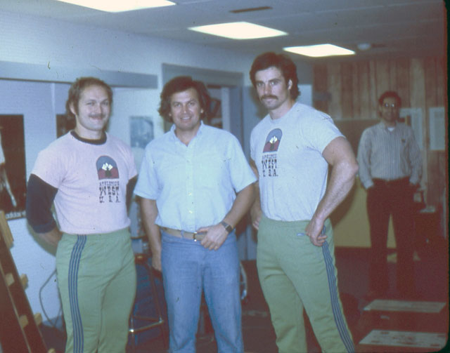
Al Feuerbach and Mac Wilkins – World Record Holders
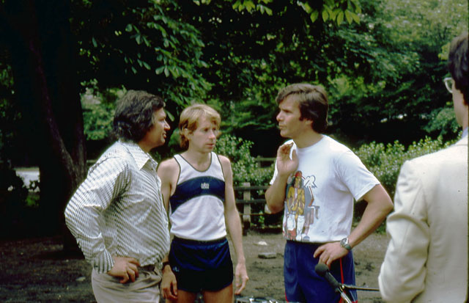
With Bill Rogers the runner and Tom Brokaw
In 1976, a group from Sports Illustrated came to visit us at the Laboratory. I was teaching a class at the University at the time so I did not know about the meeting. Ann came out of her office to talk with them and they explained to Ann that they wanted to do a lead article about my technology and me. Ann asked them how many days it would take since we were buried in projects. Kenny Moor from Sports Illustrated told her that it would take around 3 to 5 days.
“ So,” Ann said, “this could be around $25,000.”
“Don’t worry you do not have to pay Sports Illustrated to do an article on you,” Kenny Moor responded.
“You do not understand,” she said. “I mean you from Sports Illustrated will have to pay us $25,000.”
“What? Are you crazy? Sports Illustrated distributes millions of copies all around the world. This is worth millions in free advertising.”
“We do not have time for that, sorry.” Ann responded. Kenny Moor and his team shook hands with her, not believing what had just happened, and walked out of the office.
When I came home from teaching, Ann told me the story. I could not believe it. “Ann, you are crazy! We probably lost millions in future projects and getting our name out.”
I was upset for days. During the weekend, I sat in the office glaring up at the ceiling. I could not do any work. I was really depressed. On Monday, I received a call. “This is Sports Illustrated, we decided to pay you the $25,000.” I could not believe it. Ann was right again.
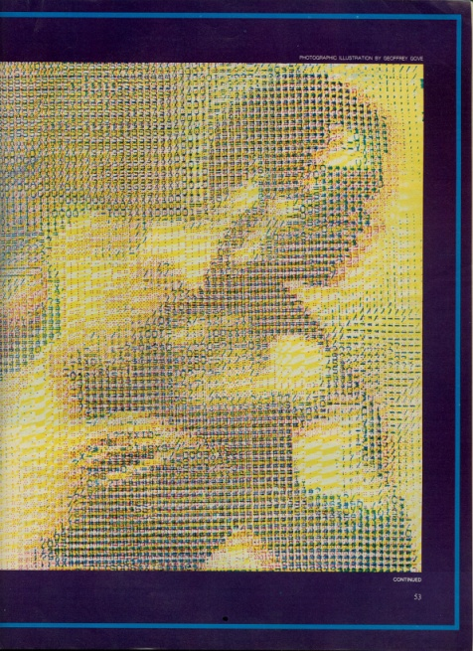
Sports Illustrated 7 page spread published at August 1977
The front page quoted the following:
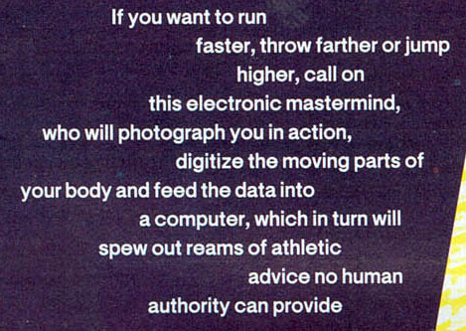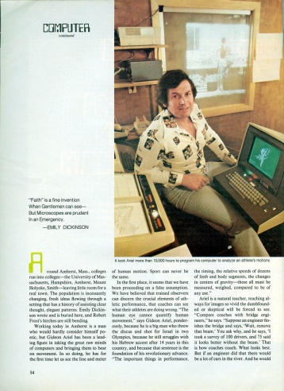
This article put us on the map. Sports Illustrated explained in detail the methods we were using and the projects that we currently were working with. One important part of the article was that Sports Illustrated interviewed some of the athletes and quoted them as to how much they appreciated our help in improving their results. It was a very positive article for us.
So our business was firmly en route. Our name, as the first and only biomechanical company, was known. But those academics and their lawyers were now seriously arming for battle.

